**Final Year Project Report**

**Tech Revolution**

**Project Team:**

**Ghulam Mustafa 1812263**

**M.Abbas Safdar 1812268**

## Project Supervisor: Muhammad Faizan Tahir

**Date: 20th June, 2022**

**Bachelor of Science in Computer Science in the Faculty of Computing and Engineering Sciences**

## Declaration of Authorship

We, Ghulam Mustafa (1812263) and Muhammad Abbas Safdar (1812268), declare that our project report titled **Tech Revolution** is our original work and has been carried out under the supervision of **Muhammad Faizan Tahir.**

We certify that this project report is submitted in partial fulfillment of the requirements for the degree of **Bachelor of Science in Computer Science** from Shaheed Zulfiqar Ali Bhutto Institute of Science and Technology (SZABIST). We also declare that this report has not been submitted or published for any degree or other similar titles.

The information provided in the report is completely authentic to the best of our knowledge and the source of references has been given where necessary.

Signed:

Ghulam Mustafa (1812263)

M. Abbas Safdar (1812268)

Date: 20th June, 2022

## Project Description

An application that caters both parties (Customers & Merchants) at an instance would be the ultimate game changer in online selling platform. Merchants could sell products at a comfortable price where the customers leaves happy and come back for more. Tech Revolution is specifically designed to cater to all such issues that could arise in the local market. It could be the gateway to bridge the gap between sellers and buyers where customers could choose a product that is best for their system as per AI recommendations.

A normal consumer won’t have to roam the market to find the perfect fit for the right price where he/she could avail of in a single click. The app would be easy to run for all involved parties to avoid any unwanted mishaps. Furthermore, there is the challenge of educating the merchants on how to sell products on the platform.

## Acknowledgement

In the name of ALLAH, the most beneficent and merciful, who gave us the knowledge and courage to work on this project and complete it successfully.

We would like to thank our supervisor “Muhammad Faizan Tahir” Lecturer at Shaheed Zulfiqar Ali Bhutto Institute of Science and Technology. He helped us throughout our project and kept motivating and guiding us when we needed some guidance. We would also like to extend our gratitude to Sir Sikandar Khan who provided us with a list of Algorithms which helped us during the initial phase of our project.

The teachers at Shaheed Zulfiqar Ali Bhutto Institute of Science and Technology were very supportive and helpful throughout our time in the university which made it easier for us to complete our projects and other course related work.

Finally, we would like to thank Shaheed Zulfiqar Ali Bhutto Institute of Science and Technology for providing us an environment, allowing us to recognize our strengths and work on them which would eventually help us in the professional work environment.

Contents

Project Proposal 1

1. Introduction 2

2. Objective 2

3. Problem Description 2

4. Methodology 3

5. Project Scope 3

6. Feasibility Study 3

7. Solution Application Areas 4

8. Tools/Technology 4

9. Expertise of the Team Members 4

10. Milestones 4

11. Project Schedule 6

12. Work Breakdown Structure 7

13. References 8

Software Requirements Specification 9

1. Introduction 10

1.1 Purpose 10

1.2 Document Conventions 10

1.3 Intended Audience and Reading Suggestions 10

1.4 Product Scope 11

1.5 References 11

2. Overall Description 11

2.1 Product Perspective 11

2.2 Product Functions 11

2.3 User Classes and Characteristics 12

2.4 Operating Environment 12

2.5 User Documentation 12

2.6 Design and Implementation Constraints 12

2.7 Assumptions and Dependencies 13

3. External Interface Requirements 13

3.1 User Interfaces 13

3.2 Hardware Interfaces 13

3.3 Software Interfaces 13

3.4 Communications Interfaces 13

4. System Features 14

4.1 System Feature 14

5. Other Nonfunctional Requirements 33

5.1 Performance Requirements 33

5.2 Safety Requirements 33

5.3 Security Requirements 33

5.4 Software Quality Attributes 33

5.5 Business Rules 33

6. Other Requirements 34

6.1 Domain Model 34

6.2 ERD: 35

6.3 Sequence Diagram: 36

6.4 Use Case Diagram 43

Software Design Specification 44

1. Introduction 45

1.1 Purpose of this document 45

1.2 Scope of the development project: 45

1.3 Definitions, acronyms, and abbreviations: 45

1.4 References: 45

1.5 Overview of document: 46

2. System Architecture Description 46

2.1 Section Overview 46

2.2 General Constraints: 46

2.3 Data Design: 47

2.4 Program Structure: 48

2.5 Alternatives Considered 48

3. Detailed Description of Components 48

3.1 Section Overview 48

3.2 Components Detail 49

4. User Interface Design 55

4.1 Section Overview: 55

4.2 Interface Design Rules: 55

4.3 GUI Components: 55

4.4 Detailed Description: 56

5. Reuse and relationships to other products 66

6. Design decisions and tradeoffs 66

7. Pseudo code for components 66

8. Appendices 67

8.1 Class Diagram: 67

8.2 Object Diagram: 68

8.3 Statechart Diagram: 69

8.4 Activity Diagrams: 70

8.5 Sequence Diagram: 77

8.6 Collaboration Diagram: 78

8.7 Use-Case Diagram: 78

8.8 Component Diagram: 79

8.9 Deployment Diagram: 79

Test Cases 81

Test Case 1: Customer Login 81

Test Case 2: Customer Sign Up 82

Test Case 3: Customer Authentication 83

Test Case 4: Customer Edit Profile 84

Test Case 5: Add to Cart 84

Test Case 6: Remove from Cart 85

Test Case 7: Proceed to checkout 85

Test Case 8: Select Payment Method 86

Test Case 9: Place Order 86

Test Case 10: Top Trending Products 87

Test Case 11: Products Correlation 87

Test Case 12: PreBuild Systems (Advanced Filtering Feature) 88

Test Case 13: Merchant Sign Up 89

Test Case 14: Merchant Login 90

Test Case 15: Upload Inventory Sheet 91

Test Case 16: View Orders 92

Test Case 17: View Inventory (Filter option applied) 92

USER MANUAL 93

PROJECT MEETING LOG SHEET 117

ITERATION PLAN 119

GANTT CHART 121

PLAGIARISM FREE CERTIFICATE 123

PLAGIARISM CERTIFICATE 124

# Project Proposal

**For Tech Revolution**

**Version 1.0 approved**

**Prepared by**

**Ghulam Mustafa 1812263**

**Muhammad Abbas Safdar 1812268**

**SZABIST**

**October 27th, 2021**

## Introduction

Tech Revolution is a trusted computer parts market which aims to facilitate the customer to explore the store and select the best possible PC build for their required work.

## Objective

To provide a platform where the user can simply build a PC according to their required needs and which meets their budget as well. With the help of Tech Revolution, the customers won’t have to invest their time and rush to the markets, instead the PC will be delivered to their doorstep.

## Problem Description

Considering how the local computer hardware market operates, it would be safe to assume that there is a considerable need for an application to cater to numerous customer demands. An application that caters both parties at an instance would be the ultimate game changer. Merchants could sell products at a comfortable price where the customers leaves happy and come back for more. In the physical aspect of the industry. We have seen numerous incidents where the merchants recommend the wrong or inappropriate product to the customer which is certainly an unfavorable occurrence. Tech Revolution is specifically designed to cater to all such issues that could arise in the local market. It could be the gateway to bridge the gap between sellers and buyers where customers could choose a product that is best for their system as per AI

recommendations. A normal consumer won’t have to roam the market to find the perfect fit for the right price where he/she could get avail of in a single click. There are a few pointers that we must consider to make the app fault resistant. The app would be easy to run for all involved parties to avoid any unwanted mishaps. Furthermore, there is the challenge of educating the merchants on how to sell and communicate with clients on the platform. Lastly, all parties must know that there could be faults or glitches in terms of the operational side of the application.

Keeping in mind the nature of the idea behind the app, team Tech Revolution is confident in overcoming most of the challenges.

## Methodology

The proposed idea is to develop an android application where customers can register and view the PC components marketplace. User profile management and details related to merchants and store inventory will be stored on a database (MY SQL or FIREBASE). A web interface will also be developed where the merchants can log in and manage their inventory and its availability.

The initial stage of development will require the creation of the required dataset and training for the recommendation system to work efficiently and provide an optimized solution for computer builds based on the needs that are to be satisfied. For the training of the recommendation system, we will be trying out a number of different recommendation algorithms to try and test which one provides the best-optimized results.

After obtaining the optimized results with the help of an optimization algorithm, a categorical classification will be done to display a range of suggested builds from best to minimum.

## Project Scope

The main purpose of Tech Revolution would be to help users find the best and optimum computer hardware products as per their needs. Additionally, the customers could by aided by app given recommendations through AI to encourage interaction and maximize sales. Only the best of the best merchants of Karachi would be listed that are willing to participate and increase their business through Tech Revolution.

With the help of following features and/or functionalities we could do this:

* + Hassle free product delivery to your doorstep.
  + User Onboarding and Profile Management.
  + Verification process for merchants.
  + Suggest optimal solution of PC builds for the required work.
  + Web-Portal for merchants to update showcase inventory and price.
  + COD (Cash on Delivery).
  + Transaction mode (EasyPaisa, Jazzcash, Skrill or BankTransfer).
  + Billing system with breakup of individual component prices

-

## Feasibility Study

##### Risks Involved:

1. Risk of Data Theft
2. Risk of Regulatory Violation

##### Resource Requirement:

1. Hosted Server
2. Dataset for Recommendation System
3. Android Application
4. Web Portal
5. Third Party APIs

## Solution Application Areas

The proposed project specifically targets the IT sector and is designed to eliminate the problems that users face when buying computer parts from local market. The prime objective of building such a system is to simplify customer’s search for products. It narrows down the variety of choices, so that the customer can focus only on those products which they are really interested in and. The benefits of building such a system includes increased sales, improved user experience and high retention rate.

## Tools/Technology

The development of this project would basically require the development of a mobile application as well as a web-based portal for Merchants. So, the following technology will be considered for use throughout the development:

* Android Studio
* Firebase
* Adobe XD
* Adobe Illustrator
* Adobe Photoshop
* Visual Studio Code
* Email Gateway
* Languages: Java/Kotlin and Python

## Expertise of the Team Members

The team is well equipped with the knowledge required for the successful completion of the application as the necessary courses related to the project (Android App development, Web Development, Software Engineering, Database Systems) have been studied previously. The implementations of UI/UX, AI Algorithms, Dataset Collection, Database Connection and other related modules will be carried out by both team members under the supervision of project advisor.

## Milestones

##### FYP 1:

1. Documentation for P1
2. Dataset Collection, Variables Selection & Cleansing
3. Research & Literature Review
4. User Interface and User Experience Design (UI/UX)

##### FYP 2:

1. Development & Implementation
   * Web Portal for Merchants
   * Android app for Users
   * Algorithm Implementation (TBD)
2. Results Testing
3. Deployment
4. Documentation for P2

## Project Schedule

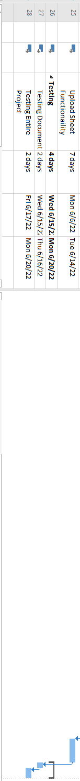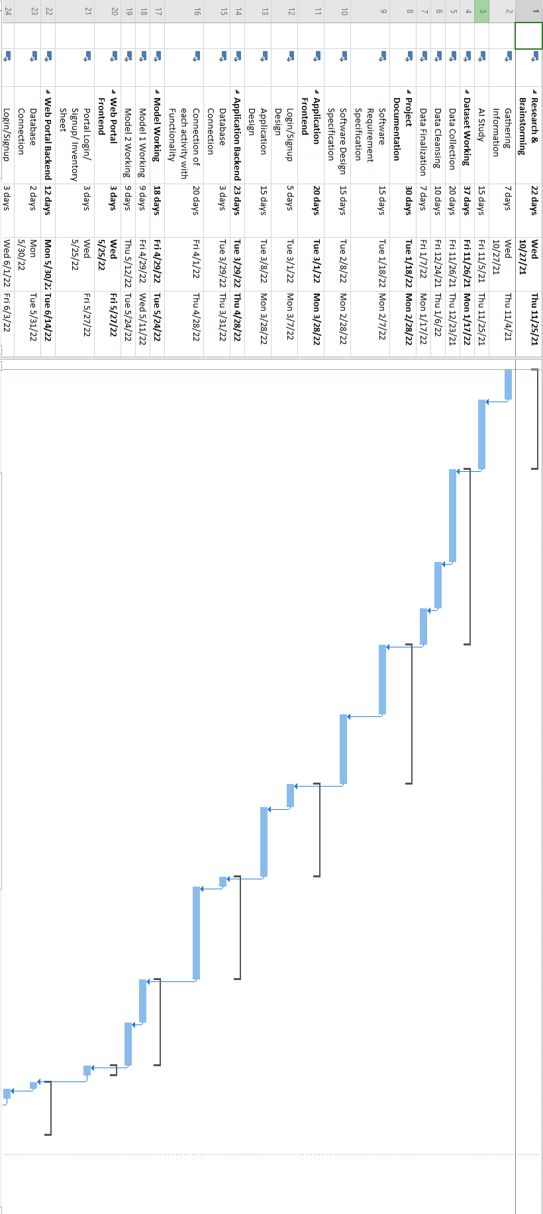

## Work Breakdown Structure

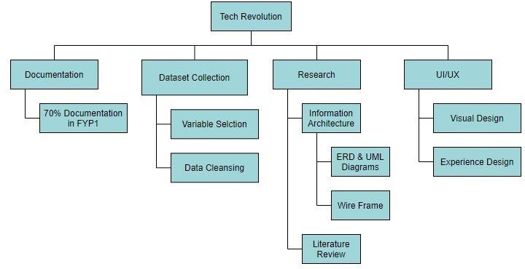

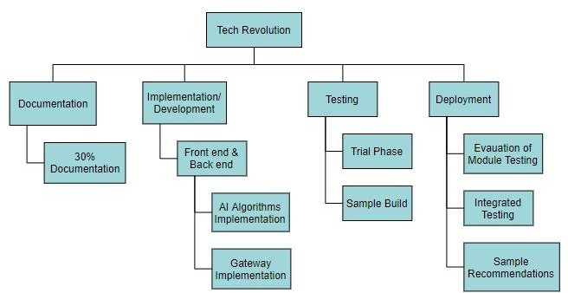

## References

Research Papers:

<https://d-nb.info/1147681678/34>

<https://builtin.com/data-science/recommender-systems>

<https://ieeexplore.ieee.org/document/895853/citations#citations>

<https://core.ac.uk/reader/212975450>

Other Reference Links:

<https://www.cpubenchmark.net/>

<https://valid.x86.fr/bench/1>

<https://towardsdatascience.com/how-i-built-my-ml-workstation-f799c1de0341>

<https://newbcomputerbuild.com/best-gaming-pc-builds-2021/>

<https://dl.acm.org/doi/abs/10.1145/3447548.3467201>

# Software Requirements Specification

**For**

**Tech Revolution**

**Version 1.0 approved**

**Prepared by**

**Ghulam Mustafa 1812263**

**Muhammad Abbas Safdar 1812268**

**SZABIST**

**February 9th, 2022**

## Introduction

### 1.1 Purpose

Tech Revolution is a trusted computer parts market which aims to facilitate the customer to explore the store and select the best possible PC build for their required work.

### Document Conventions

|  |  |
| --- | --- |
| Headings | Font Size: 18pts  Font Style: New Times Roman |
| Sub Headings | Font Size: 14pts  Font Style: New Times Roman |
| Regular Text | Font Size: 11pts  Font Style: New Times Roman |

### 1.3 Intended Audience and Reading Suggestions

The intended audience of this document would be those individuals who are looking to buy PC according to their requirements. The main objective of this project is to provide the customer a series of options from which he/she can pick a system that satisfies their basic needs. This project will also provide an opportunity to sellers where they can sell their products on a trusted platform. Furthermore, Brief outline of the document is:

1. Introduction
2. Overall Description.
3. External Interface Requirements.
4. System Features.
5. Other Non-Functional Requirements.
6. Other Requirements.

### 1.4 Product Scope

* + 1. The main purpose of Tech Revolution would be to help users find the best and optimum computer hardware products as per their needs. Additionally, the customers could by aided by app given recommendations through AI to encourage interaction and maximize sales.
    2. Only the best of the best merchants of Karachi would be listed that are willing to participate and increase their business through Tech Revolution.

### 1.5 References

https://krazytech.com/projects/sample-software-requirements-specificationsrs-report-airline-database https://[www.slideshare.net/inderjeetsingh90/srs-for-project](http://www.slideshare.net/inderjeetsingh90/srs-for-project)

https://[www.uml-diagrams.org/index-examples.html](http://www.uml-diagrams.org/index-examples.html)

## Overall Description

### Product Perspective

Tech Revolution is a self-contained product that aims to provide a platform for the users where they get to know which PC components are best paired for providing maximum performance for their type of work.

Components of Tech Revolution are:-

-Re-design marketplace UX.

-Verified Sellers can update inventory

-PC build recommendation

-Pre-Order

-Payment gateway

-User’s Information

### Product Functions

* Hassle free product delivery to your doorstep.
* User Onboarding and Profile Management.
* Verification process for merchants.
* Suggest optimal solution of PC builds for the required work.
* Web-Portal for merchants to update showcase inventory and price.
* COD (Cash on Delivery).
* Transaction mode (EasyPaisa, Jazzcash or BankTransfer).
* Billing system with breakup of individual component prices

### User Classes and Characteristics

Users: Users of Tech Revolution should be able to sign-up or login if they already signed-up. User can browse through different pc component categories on the android application. They can also request for a recommendation by providing information related to their purpose of use. Users can update and edit their profile

Sellers: Sellers of Tech Revolution should be able to sign-up or login if they already signed-up. They can verify their identity in order to get registered in the verified seller list. Sellers can update the inventory they want to showcase through the web portal. They can also manage their sales and pending payments through the web portal dashboard.

Store Admin: Store Admin of Tech-Revolution will have complete authority to add/update or delete a user/seller. They will be the ones scheduling order delivery and dispatch. Verification of the seller will also be done by the store admin.

### Operating Environment

Database: Firebase

Environment: Android studio IDE, Firebase Console, (Web portal environment)

### User Documentation

* + - Software Requirement Specification (SRS)
    - System Sequence Diagram (SSD)
    - Use Cases
    - Test Cases
    - Entity Relationship Diagram (ERD)
    - Domain model
    - Iteration plan

### Design and Implementation Constraints

-The information of all the users must be stored in a database to store the data for later use.

* User may access from any phone that has internet browsing capabilities and an internet connection.

-User should know their valid username and passwords to access their account.

### Assumptions and Dependencies

The following assumptions and dependencies are a must for Tech Revolution:

* All devices with Android OS supporting previous OS versions as well.
* Internet accessibility supported.
* Anaconda, MS Office, Firebase, and Android Studio pre-installed

## External Interface Requirements

### User Interfaces

-Web Front-end software: Angular.

-App Front-end software: Android.

-Back-end software: Firebase

### Hardware Interfaces

The hardware interface for user is a device running the Android operating system capable enough to run the application smoothly.

### Software Interfaces

We use Android studio (Java) Programming language for writing the code for the project. Adobe Illustrator will also be used to develop some designs for our application. Furthermore, for the need of database, we will use firebase which we fulfil our requirement. In addition to that, we will be using tensor flow and keras library for training the model. Pandas library will be used for reading and data manipulation of csv files.

### Communications Interfaces

When a customer signs up to the App, an e-mail notification will be sent to the email provided by the customer for verification purpose. In order to achieve the service, having a strong and stable internet connection is mandatory.

## System Features

### System Feature

Sign up:

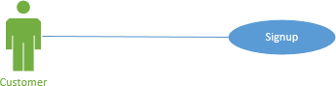

##### Author (s): Ghulam Mustafa Date: _3/12/2021 Version: 1.0

|  |  |  |  |
| --- | --- | --- | --- |
| **USE CASE** NAME**:** | Sign up | | **USE CASE TYPE** |
| **USE CASE ID:** | TR-001 | |  |
| **PRIORITY:** | 1 | | Business Requirements ✓ |
| **TRIGGER:** | This user case is initiated when a customer wants to register to the App. | |  |
| **PARTICIPATING ACTORS:** | Customer, Merchant | | |
| **DESCRIPTION:** | This use case describes how a user will sign up on the Tech Revolution app. | | |
| **PRE-CONDITION:** | None | | |
| **TYPICAL COURSE OF EVENTS:** | **Actor Action** | **System Response** | |
| User Taps Sign Up | Shows Sign Up Page | |
| User Enters Email | Confirmation Email Sent | |
| User enters their name | Sets user’s name | |
| User enters pin | Ask to re-enter pin | |
| User re-enters pin | Show Login page | |
| **ALTERNATE COURSES:** | None | | |
| **POST-CONDITION:** | User account is created. | | |

Login:

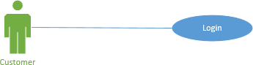

##### Author (s): Ghulam Mustafa Date: _3/12/2021 Version: 1.0

|  |  |  |  |
| --- | --- | --- | --- |
| **USE CASE NAME:** | Login | | **USE CASE TYPE** |
| **USE CASE ID:** | TR-002 | |  |
| **PRIORITY:** | 1 | | Business Requirements ✓ |
| **TRIGGER:** | This user case is initiated when a customer wants to login to the App. | |  |
| **PARTICIPATING ACTORS:** | Customer, Merchant | | |
| **DESCRIPTION:** | This use case describes how a user will login on the Tech Revolution app. | | |
| **PRE-CONDITION:** | Account must be created | | |
| **TYPICAL COURSE OF EVENTS:** | **Actor Action** | **System Response** | |
| User Taps Login | Shows Login Page | |
| User Enters Email | Verify Credentials | |
| User enters pin |
| User re-enters pin | Show homescreen | |
| **ALTERNATE COURSES:** | None | | |
| **POST-CONDITION:** | Account Active | | |

AI Recommended Items:

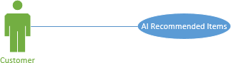

##### Author (s): Ghulam Mustafa Date: _3/12/2021 Version: 1.0

|  |  |  |  |
| --- | --- | --- | --- |
| **USE CASE NAME:** | AI Recommended Items | | **USE CASE TYPE** |
| **USE CASE ID:** | TR-003 | |  |
| **PRIORITY:** | 1 | | Business Requirements  ✓  Extension |
| **TRIGGER:** | This user case is initiated when a customer wants to see AI recommended items. | |  |
| **PARTICIPATING ACTORS:** | Customer | | |
| **DESCRIPTION:** | This use case describes the list user will get when user wants to see the AI based results. | | |
| **PRE-CONDITION:** | User must be logged in | | |
| **TYPICAL COURSE OF EVENTS:** | **Actor Action** | **System Response** | |
| Customer requests AI recommended items | AI interface generates a list  AI Interface presents items based on 2 models | |
| **ALTERNATE COURSES:** | None | | |

Products:

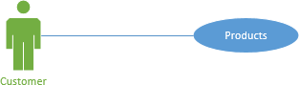

##### Version: 1.0

|  |  |  |  |
| --- | --- | --- | --- |
| **USE CASE NAME:** | Products | | **USE CASE TYPE** |
| **USE CASE ID:** | TR-004 | | Abstract: |
| **PRIORITY:** | 1 | | Business Requirements  ✓  Extension |
| **TRIGGER:** | This user case is initiated when a customer explores the store to selects product/’s | |  |
| **PARTICIPATING ACTORS:** | Customer | | |
| **DESCRIPTION:** | This use case describes the procedure when the customer browses  products. | | |
| **PRE-CONDITION:** | Must be logged in | | |
| **TYPICAL COURSE OF EVENTS:** | **Actor Action** | **System Response** | |
| Customer selects a product | -Product is added to the cart | |
| -A list of product details are displayed | |
| -Total cost of product is  displayed | |
| **ALTERNATE COURSES:** | None | | |
| **POST-CONDITION:** | Moves to payment process | | |

Add to cart:

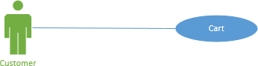

##### Author (s): M Abbas Safdar Date: _3/12/2021 Version: 1.0

|  |  |  |  |
| --- | --- | --- | --- |
| **USE CASE NAME:** | Cart | | **USE CASE TYPE** |
| **USE CASE ID:** | TR-005 | | Abstract: |
| **PRIORITY:** | 1 | | Business Requirements  ✓  Extension |
| **TRIGGER:** | This user case is initiated when a customer adds to the cart. | |  |
| **PARTICIPATING ACTORS:** | Customer | | |
| **DESCRIPTION:** | This use case describes the procedure when the customer moves to the cart. | | |
| **PRE-CONDITION:** | Item/’s must be selected | | |
| **TYPICAL COURSE OF EVENTS:** | **Actor Action** | **System Response** | |
| Customer selects a item | -Item is added to the cart | |
| -A list of item details is displayed | |
| -Total cost of item is displayed | |
| **ALTERNATE COURSES:** | None | | |
| **POST-CONDITION:** | Moves to payment process | | |

Component’s Price:

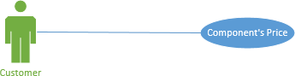

##### Author (s): M Abbas Safdar Date: _4/12/2021 Version: 1.0

|  |  |  |  |
| --- | --- | --- | --- |
| **USE CASE NAME:** | Component’s Price | | **USE CASE TYPE** |
| **USE CASE ID:** | TR-006 | | Abstract: |
| **PRIORITY:** | 1 | | Business Requirements    Extension  ✓ |
| **TRIGGER:** | This user case is initiated when a customer presses the cart button | |  |
| **PARTICIPATING ACTORS:** | Customer | | |
| **DESCRIPTION:** | This use case describes the procedure when the customer proceeds towards  the cart in order to view component’s price | | |
| **PRE-CONDITION:** | Product must be selected | | |
| **TYPICAL COURSE OF EVENTS:** | **Actor Action** | **System Response** | |
| Customer selects cart button | -Cart page is displayed | |
| -Each component’s price is  displayed | |
| **ALTERNATE COURSES:** | None | | |
| **POST-CONDITION:** | Move to payment process | | |

Payment Process:

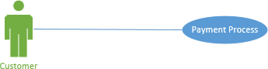

##### Author (s): Ghulam Mustafa Date: _4/12/2021 Version: 1.0

|  |  |  |  |
| --- | --- | --- | --- |
| **USE CASE NAME:** | Payment Process | | **USE CASE TYPE** |
| **USE CASE ID:** | TR-007 | |  |
| **PRIORITY:** | 1 | | Business Requirements ✓ |
| **TRIGGER:** | This user case is initiated when a customer completes add to cart process. | |  |
| **PARTICIPATING ACTORS:** | Customer | | |
| **DESCRIPTION:** | This use case describes the procedure when the customer proceeds towards  payment process and selects desired payment method. | | |
| **PRE-CONDITION:** | Product must be selected | | |
| **TYPICAL COURSE OF EVENTS:** | **Actor Action** | **System Response** | |
| Customer selects payment process button | -Payment process page is displayed | |
| -Display a list of payment methods. | |
| -Wait for customer to select the  desired payment method | |
| **ALTERNATE COURSES:** | None | | |
| **POST-CONDITION:** | Print Receipt | | |

**Author (s): Ghulam Mustafa Date: _4/12/2021 Version: 1.0**

|  |  |  |  |
| --- | --- | --- | --- |
| **USE CASE NAME:** | View Receipt | | **USE CASE TYPE** |
| **USE CASE ID:** | TR-008 | |  |
| **PRIORITY:** | 1 | | Business Requirements ✓ |
| **TRIGGER:** | This user case is initiated when a customer places an order | |  |
| **PARTICIPATING ACTORS:** | Customer | | |
| **DESCRIPTION:** | This use case describes the procedure when the customer pays for bill and  wants to view the receipt for later use. | | |
| **PRE-CONDITION:** | Order must be placed | | |
| **TYPICAL COURSE OF EVENTS:** | **Actor Action** | **System Response** | |
| Customer places an order | -Order details are gathered | |
| -Payment receipt is generated | |
| -Order receipt is displayed to the  customer | |
| **ALTERNATE COURSES:** | None | | |
| **POST-CONDITION:** | None | | |

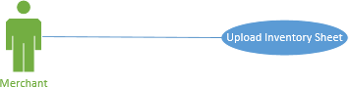

**Author (s): Ghulam Mustafa Date: _5/12/2021 Version: 1.0**

|  |  |  |  |
| --- | --- | --- | --- |
| **USE CASE NAME:** | Upload Inventory Sheet | | **USE CASE TYPE** |
| **USE CASE ID:** | TR-09 | | Abstract: |
| **PRIORITY:** | 1 | | Business Requirements  ✓  Extension |
| **TRIGGER:** | This user case is initiated when a Merchant selects upload sheet button | |  |
| **PARTICIPATING ACTORS:** | Merchant | | |
| **DESCRIPTION:** | This use case describes the procedure when the Merchant logs into the  system and uploads the daily product sheet. | | |
| **PRE-CONDITION:** | Merchant must be logged in | | |
| **TYPICAL COURSE OF EVENTS:** | **Actor Action** | **System Response** | |
| Merchant presses upload sheet button | Opens file explorer | |
| Merchant selects the file | Loads the file | |
| Merchant presses Update Button | Display Successfully Updated | |
| **ALTERNATE COURSES:** | None | | |
| **POST-CONDITION:** | Update the inventory sheet | | |

**Author (s): M Abbas Safdar Date: _5/12/2021 Version: 1.0**

|  |  |  |  |
| --- | --- | --- | --- |
| **USE CASE NAME:** | Recommended Items | | **USE CASE TYPE** |
| **USE CASE ID:** | TR-010 | | Abstract: |
| **PRIORITY:** | 1 | | Business Requirements  ✓  Extension |
| **TRIGGER:** | This user case is initiated when Recommended items are requested | |  |
| **PARTICIPATING ACTORS:** | AI Interface, Customer | | |
| **DESCRIPTION:** | This use case describes the procedure where the AI Interface uses the parameters provided by the customer as input and generates optimum  solution. | | |
| **PRE-CONDITION:** | Customer must be logged in  Customer must have entered parameters | | |
| **TYPICAL COURSE OF EVENTS:** | **Actor Action** | **System Response** | |
| Entertaining the requests received for the  AI based item recommendation | The system processes the  requests | |
| AI Interface generates recommendation  based on the parameters provided by the customer. | A list of multiple build  combinations is displayed to the customer. | |
| **ALTERNATE COURSES:** | Browse store for combining your own new pc build. | | |
| **POST-CONDITION:** | The add to cart feature is called | | |

Profile Management:

##### Author (s): M Abbas Safdar Date: _5/12/2021 Version: 1.0

|  |  |  |  |
| --- | --- | --- | --- |
| **USE CASE NAME:** | Profile Management | | **USE CASE TYPE** |
| **USE CASE ID:** | TR-013 | | Abstract: |
| **PRIORITY:** | 1 | | Business Requirements ✓  Extension |
| **TRIGGER:** | This user case is initiated when store admin collects and verify documents provided by the merchant to update his status as verified. | |  |
| **PARTICIPATING ACTORS:** | Store Admin | | |
| **DESCRIPTION:** | This use case describes the part where the merchant provides identity verification details in order to get verified status and can start showcasing his inventory. | | |
| **PRE-CONDITION:** | Admin Logged in, Merchant must’ve submitted identity verification documents. | | |
| **TYPICAL COURSE OF EVENTS:** | **Actor Action** | **System Response** | |
| Store Admin selects the Merchant  Verification Requests | Display the details of the Merchant.  -The attachments uploaded by the Merchant are shown. | |
| Store Admin checks the profile and the  documents and then changes the verification status of Merchant from “Pending” to “Verified” | The system updates the database  with the updated verification status and upgrades the Merchant’s privileges. | |
| **ALTERNATE COURSES:** | Wrong documents provided by merchant. Verification Failed. | | |
| **POST-CONDITION:** | Make merchant eligible to use the Upload Inventory Sheet Feature. | | |

## Other Nonfunctional Requirements

### Performance Requirements

The main performance requirements include swift response time and refresh rate of the application. For instance, if a customer wants to buy a product, the items page must load all items without lagging. Data must be fetched and filtered as per the user demands which indicates data retrieval from backend must be addressed smoothly.

### Safety Requirements

No safety requirements apply on Tech Revolution.

### Security Requirements

The use of firebase functionality ensures a secure data backup in case of an unexpected security breach. This will ensure privacy and data integrity which is a must to run the app.

### Software Quality Attributes

* Portability: the app is supported on Android mobile phones which ensures it can be anytime and anywhere with a stable internet connection.
* Reliability: data is secured on a remote backup file handled by the developers.
* Interoperability: maximum efficiency in terms of connected interfaces to take user from one screen to another when required.
* Flexibility: the app lists a large data volume and is capable of accommodating maximum requests.

### Business Rules

* The admin solely holds all data handling rights. This includes updating, editing, deleting, and so on.
* The users have all rights to deny entering any personal information if requested by the application.
* The vendors cannot directly contact consumers for selling products and vice versa to maintain harmony.

## Other Requirements

### Appendix A: Glossary:

N/A

### Appendix B: Analysis Model

### 6.1 Domain Model

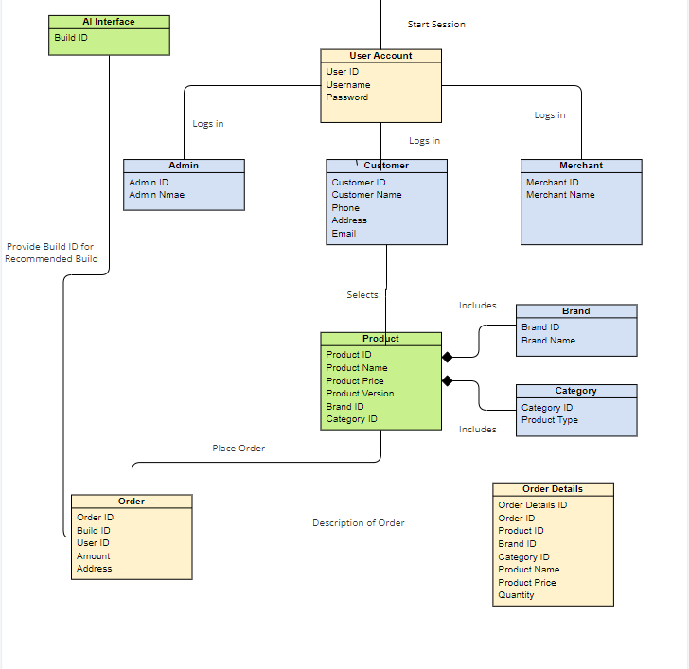

### 6.2 ERD:

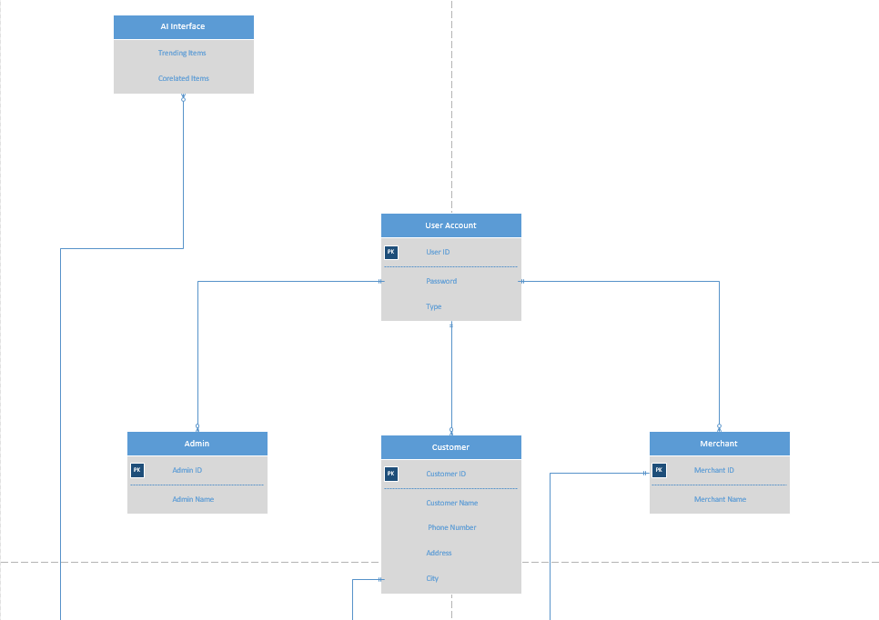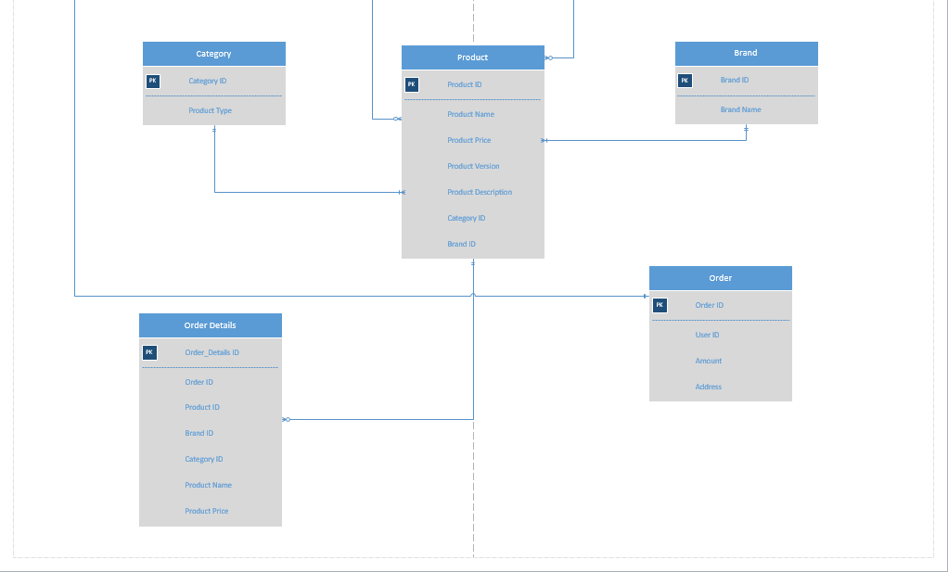

### 6.3 Sequence Diagram:

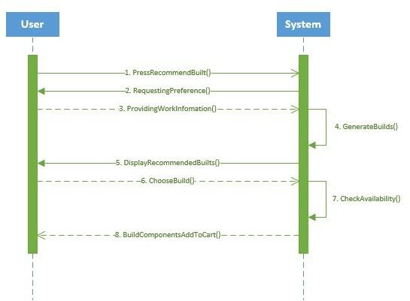

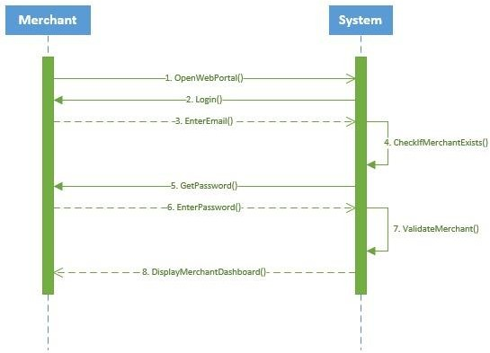

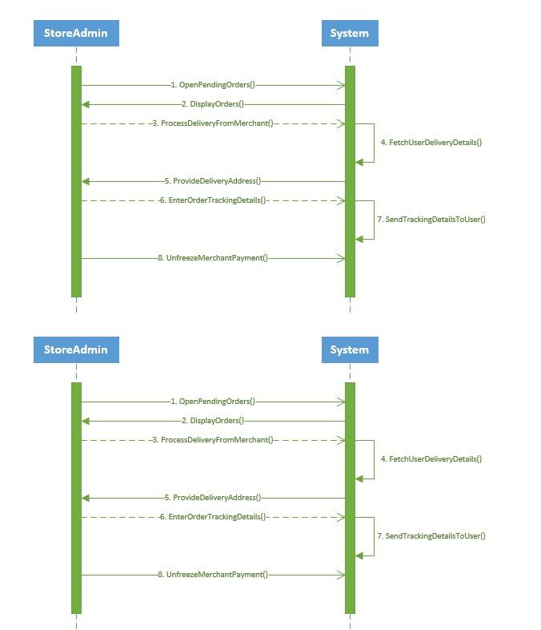

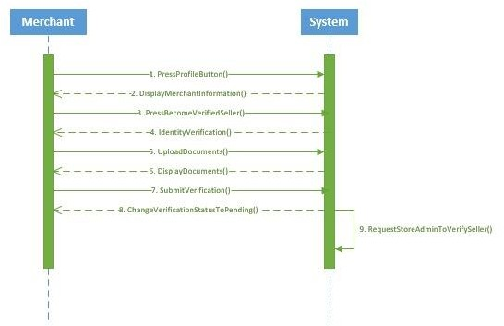

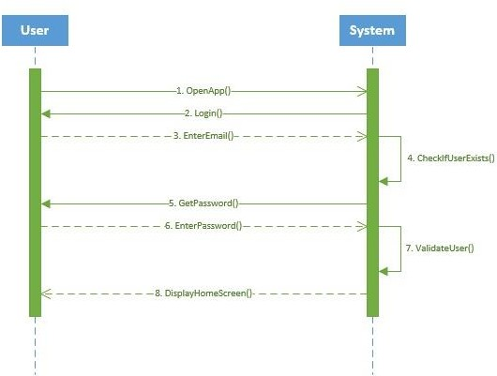

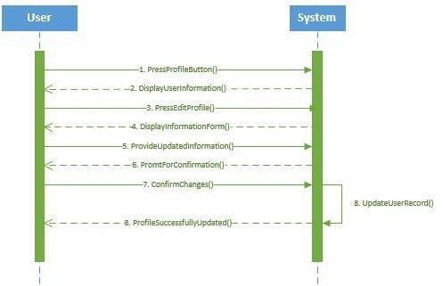

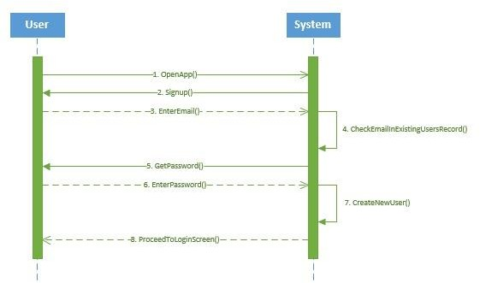

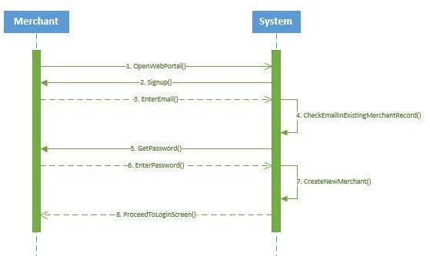

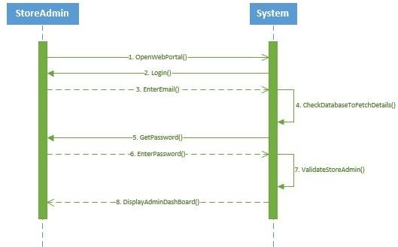

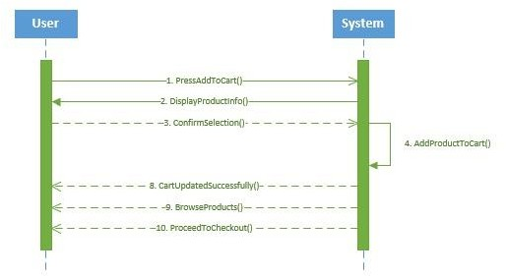

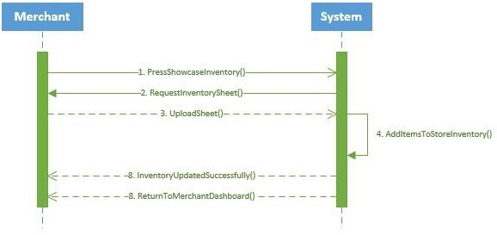

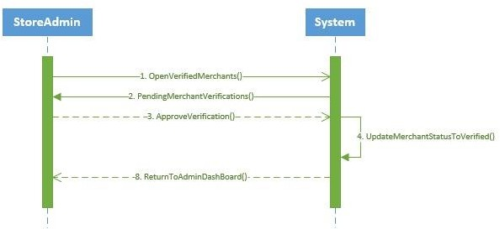

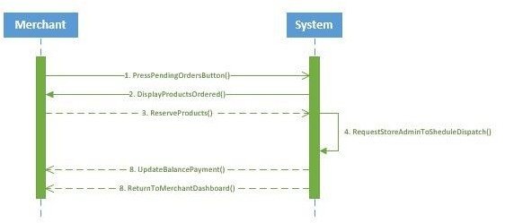

### 6.4 Use Case Diagram

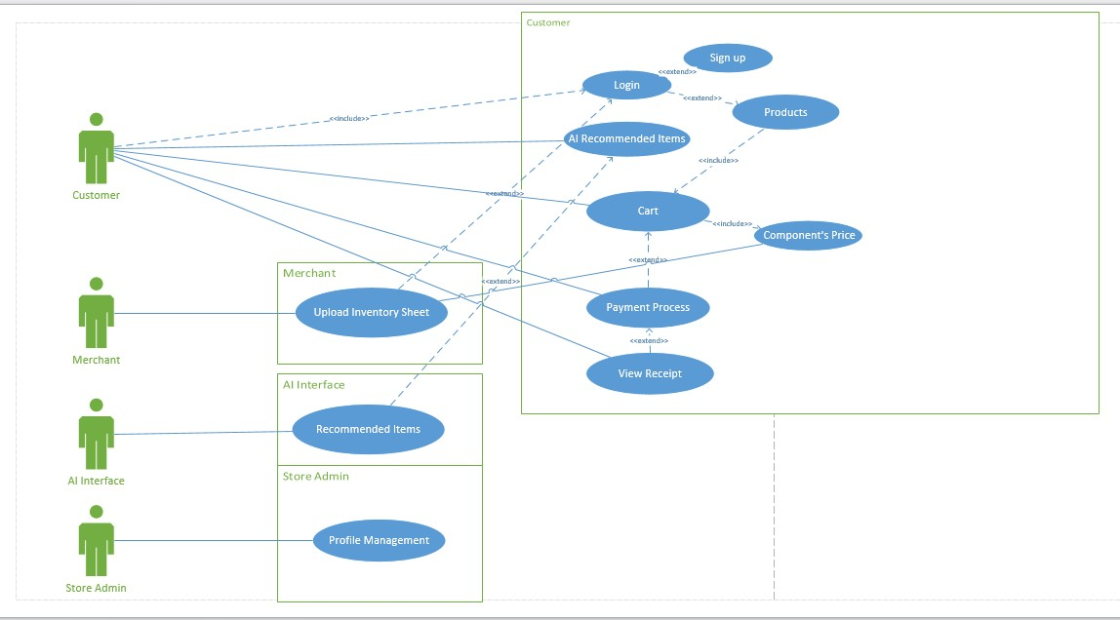

# Software Design Specification

**For Tech Revolution**

**Version 1.0 approved**

**Prepared by**

**Ghulam Mustafa 1812263**

**Muhammad Abbas Safdar 1812268**

**SZABIST**

**February 9th, 2022**

## Introduction

### Purpose of this document

The purpose of this SDS document is to provide a technical overview of our software product, its parameters and goals. This document describes the project's architecture and its components, hardware and software requirements.

### Scope of the development project:

The main purpose of Tech Revolution would be to help users find the best and optimum computer hardware products as per their needs. Additionally, the customers could by aided by app given recommendations through AI to encourage interaction and maximize sales.

Only the best of the best merchants of Karachi would be listed that are willing to participate and increase their business through Tech Revolution.

### Definitions, acronyms, and abbreviations:

|  |  |
| --- | --- |
| Headings | Font Size: 18pts  Font Style: New Times Roman |
| Sub Headings | Font Size: 14pts  Font Style: New Times Roman |
| Regular Text | Font Size: 11pts  Font Style: New Times Roman |

### References:

N/A

### Overview of document:

This document will contain descriptions of system architecture, components. Screenshots for the graphical user interface will be provided. UML Diagrams will be attached at the end of this document in section 5. These UML diagrams will contain the following:

* + 1. System Block Diagram
    2. Class Diagram
    3. Object Diagram
    4. State Chart Diagram
    5. Activity Diagram
    6. Sequence Diagram
    7. Collaboration Diagram
    8. Use Case Diagrams
    9. Component Diagram
    10. Deployment Diagram

## System Architecture Description

### Section Overview

This section provides an overview and rationale for the program's data and architectural design decisions.

### General Constraints:

* + - Database: Firebase
    - Environment: Android studio IDE, Firebase Console
    - Platform: Android, Java.

### Data Design:

|  |  |  |
| --- | --- | --- |
| **S. No** | **Table Name** | **Description** |
| 1. | User | User_ID Number  User_Name Varchar (200)  NOTNULL  User_Number Number (11)  User_Passcode Varchar (8)  User_Status Varchar (10)  Email_ID Varchar(50) |
| 2. | UserPasscode | User_Passcode Varchar (8)  User_ID Number  Email_ID Varchar (50) |
| 3. | Order | Order ID Number  Order Date Date |
| 4. | Product | Product ID Number  Product Name Varchar(100)  Product Price Float |
| 5. | Admin | Admin_ID Number  Admin_Name Varchar (200)  Admin_Number Number  Admin_Passcode Number |
| 6. | AdminPassword | Admin_Password Varchar(8)  Admin_ID Number |

### Program Structure:

Functional Hierarchy Diagram:

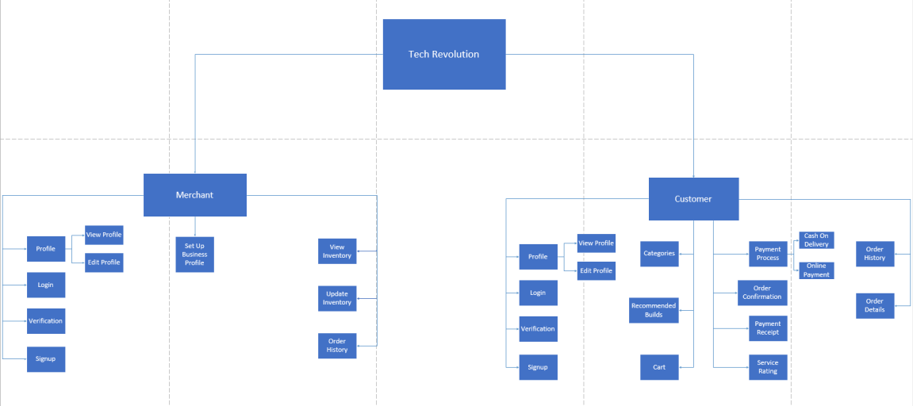

### Alternatives Considered

There are no alternatives considered with regards to architectural designing options. The UML approach is best suited for the architectural designing of application as it provides an open approach as compared to other designing models.

## Detailed Description of Components

### Section Overview

This section gives the reader an overview for the program's data as well as architectural design of the system. This section provides the general constraints that have a significant impact on the system, it provides the structure of the data, and how the system interacts with the data. The structure of the program is also included in this section.

### Components Detail

|  |  |
| --- | --- |
| Identification | Authentication |
| Type | Class/Form |
| Purpose | The Authentication Component assures that only Merchant and Customers can access the system for the purpose of buying and selling. |
| Subordinates | This Component contains links to the following screens:   * Signup * Login |
| Dependencies | The Login Screen moves the user to:   * Dashboard   The Signup Screen moves the user to:   * Login |
| Interfaces | The buttons are contained in the bottom half of the screen. The screen is designed to be easy to view for clear and better display. |
| Resources | Database Access Requirements: Access to the user information found in the appropriate database tables for authentication purpose. |
| Processing | The only type of processing required is inputting information into the text boxes and navigating to other forms using buttons provided in the bottom half of the screen. Each button processes and takes the user to a different screen that corresponds to the button that the user selects. |
| Data | The data for the Sign up screen is Full name, Password, Contact and Email entered by the user.  The data for Login screen is Email and Password. |

|  |  |
| --- | --- |
| Identification | Customer |
| Type | Class |
| Purpose | The Customer Component carries out the operations of browsing product, select particular build and placing order. |
| Subordinates | This Component contains links to the following screens:   * Profile Management * Browse Product |
| Dependencies | The Customer component must have gone through the authentication component so that he/she can browse products and manage profile. |
| Interfaces | The buttons are contained in the middle part of the screen with a search bar on the top. The screen is designed to be easy to view for clear and better display. |
| Resources | Database Access Requirements: Access to the user information found in the appropriate database tables for authentication purpose.  Access to Inventory: Access to inventory to be enabled by the Merchant so that customer to can view desired products. |
| Processing | The type of processing required is inputting information into the text boxes and navigating to other forms/screens using buttons provided. |
| Data | The data required for browsing product is product name.  The data required for updating profile is first name and last name. |

|  |  |
| --- | --- |
| Identification | Cart |
| Type | Class |
| Purpose | The Cart Component functionality is to display information of the items selected by the customer and move checkout/payment process. |
| Subordinates | This Component contains links to the following screens:   * Checkout * Payment Process |
| Dependencies | The Cart component must have gone through the process of product/build selection so that the customer can move to checkout and pay for the order. |
| Interfaces | The buttons are contained in the lower half of the screen. The screen contains information about the products and is designed for clear and better display. |
| Resources | Database Access Requirements: Access to the user information found in the appropriate database tables for authentication purpose.  Access to Inventory: Access to inventory to be enabled by the Merchant so that customer to can view desired products.  Access to Payment function: After moving from cart, then comes the ultimate part of payment process. |
| Processing | The type of processing required is selection of products and navigating to other forms/screens using buttons provided. The component also requires processing of payment with the desired method that the customer selects. |
| Data | The data required for Product information is its description which includes it name, price etc. The data required for payment method is the credit card details in case of online payment. |

|  |  |
| --- | --- |
| Identification | Orders |
| Type | Class |
| Purpose | The Orders Component works by processing the information of the items selected by the customer and moves to cart. |
| Subordinates | This Component contains links to the following screens:   * View Cart * Product Information |
| Dependencies | The Orders component must have gone through the authentication component so that he/she can browse product and place orders. |
| Interfaces | The buttons are contained in the lower half of the screen. The screen contains information about the products and is designed for clear and better display. |
| Resources | Database Access Requirements: Access to the user information found in the appropriate database tables for authentication purpose.  Access to Inventory: Access to inventory to be enabled by the Merchant so that customer to can view desired products. |
| Processing | The type of processing required is selection of products and navigating to other forms/screens using buttons provided. |
| Data | The data required for Product information is its description which includes it name, price etc. |

|  |  |
| --- | --- |
| Identification | Inventory |
| Type | Class |
| Purpose | The Inventory Component functionality is to display information of the products uploaded by the Merchant on his/her store. |
| Subordinates | This Component contains links to the following screens:   * Browsing Product * Orders |
| Dependencies | The Inventory component must be accessed by customer/merchant after successful authentication process. After that the customer should move to the search component for browsing the products. |
| Interfaces | The Component contains complete information about each and every product available at the store. It is displayed in the form of listing where customer can go through each listing in detail. |
| Resources | Database Access Requirements: Access to the user information found in the appropriate database tables for authentication purpose.  Access to Inventory: Access to inventory to be enabled by the Merchant so that customer to can view desired products. |
| Processing | The type of processing required is inputting information into the text boxes and navigating to other forms/screens using buttons provided. |
| Data | The data required for searching a specific product is the product name.  The data required for Product information is its description which includes it name, price etc. |

|  |  |
| --- | --- |
| Identification | Search Engine |
| Type | Class |
| Purpose | The Search engine Component functionality is to display information of the products searched by the customer. |
| Subordinates | This Component contains links to the following screens:   * Product Listing. * Inventory |
| Dependencies | The Search engine component must be accessed by customer after successful authentication process. After that the customer should move to the search component for browsing the products. |
| Interfaces | The Component contains search bar to look for the product searched by the customer. The result is displayed in the form of listing where customer can go through each listing in detail. |
| Resources | Database Access Requirements: Access to the user information found in the appropriate database tables for authentication purpose.  Access to Inventory: Access to inventory to be enabled by the Merchant so that customer to can view desired products. |
| Processing | The type of processing required is inputting information into the text boxes and navigating to other forms/screens using buttons provided. |
| Data | The data required for searching a specific product is the product name. |

## User Interface Design

### Section Overview:

In this section we will be showing you the graphical user interface of the program. The graphical user interface followed some preset rules and there were many components used.

### 4.2 Interface Design Rules:

The rules defined for the user interface design behind **Tech Revolution** is as follows:

* + - Interactive screens for users
    - Screens must follow the accurate paths for correct and absolute display results.
    - Interface must provide maximum usability
    - Minimal user inputs
    - There must be significant user control.

### 4.3 GUI Components:

* Edittext
* Textview
* Imageview
* Screen Buttons

### 4.4 Detailed Description:

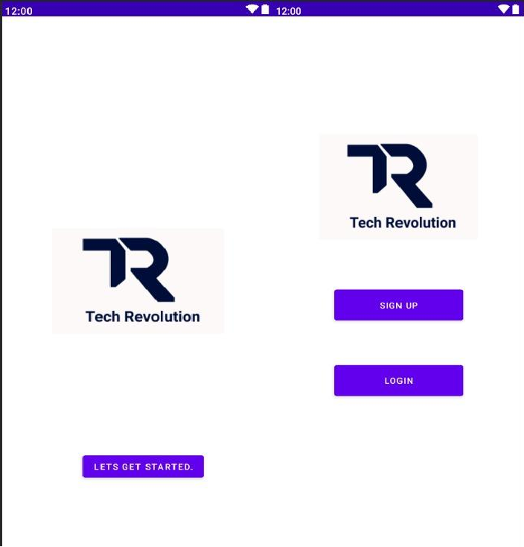

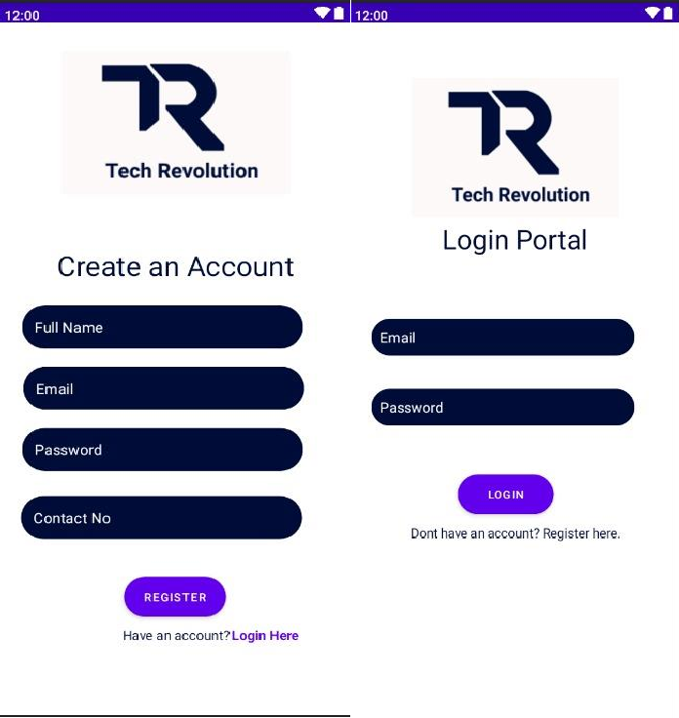

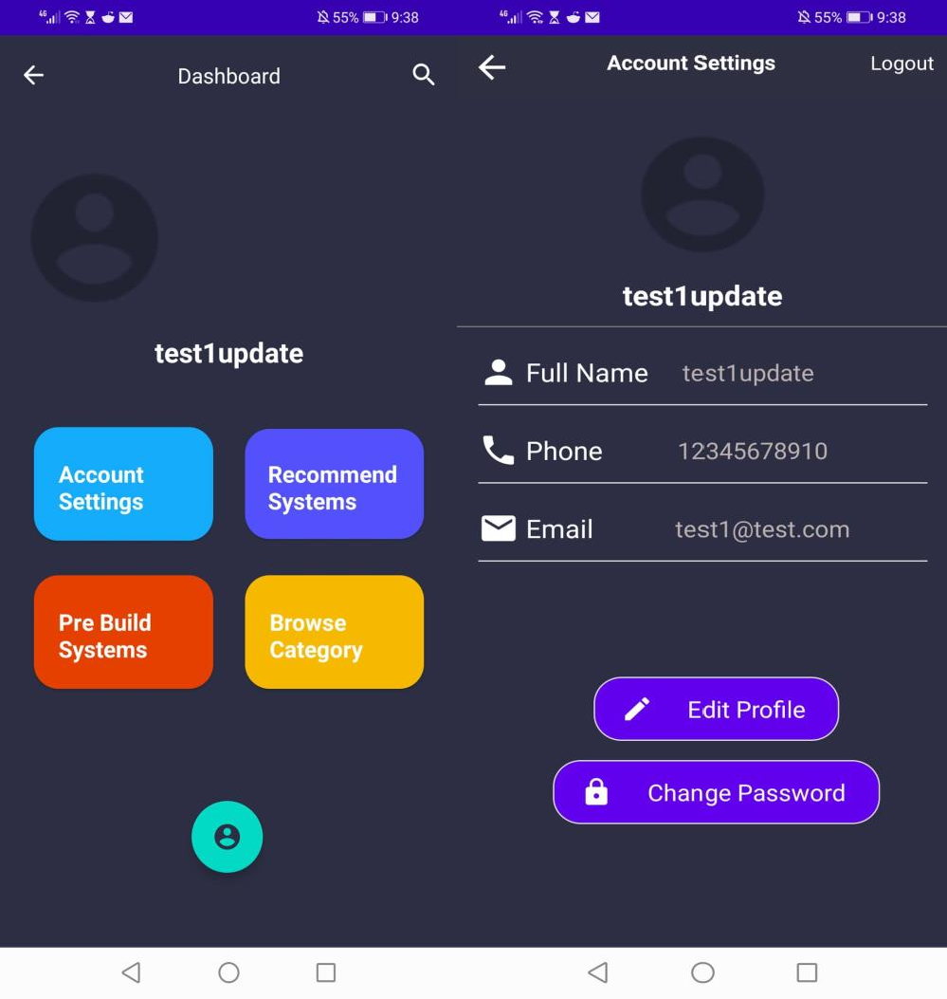

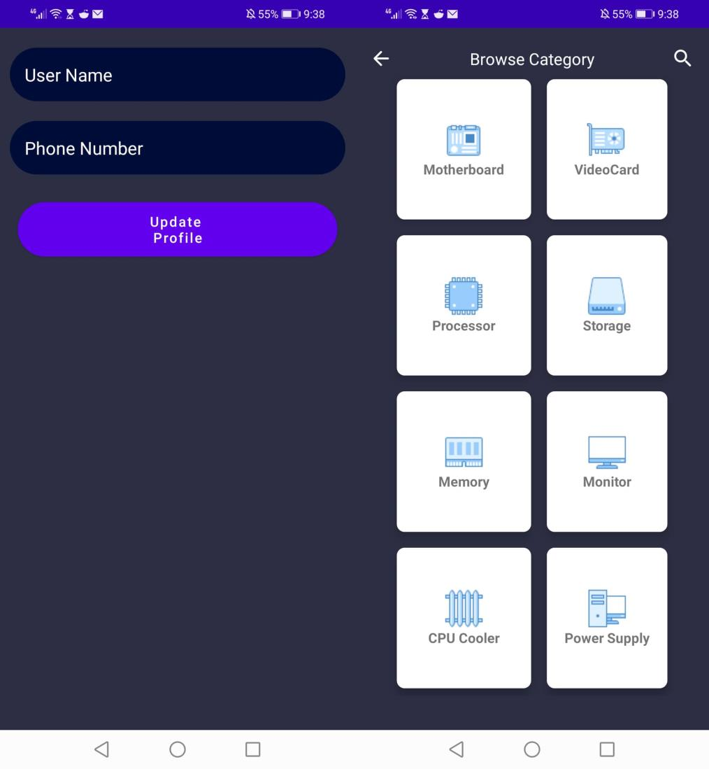

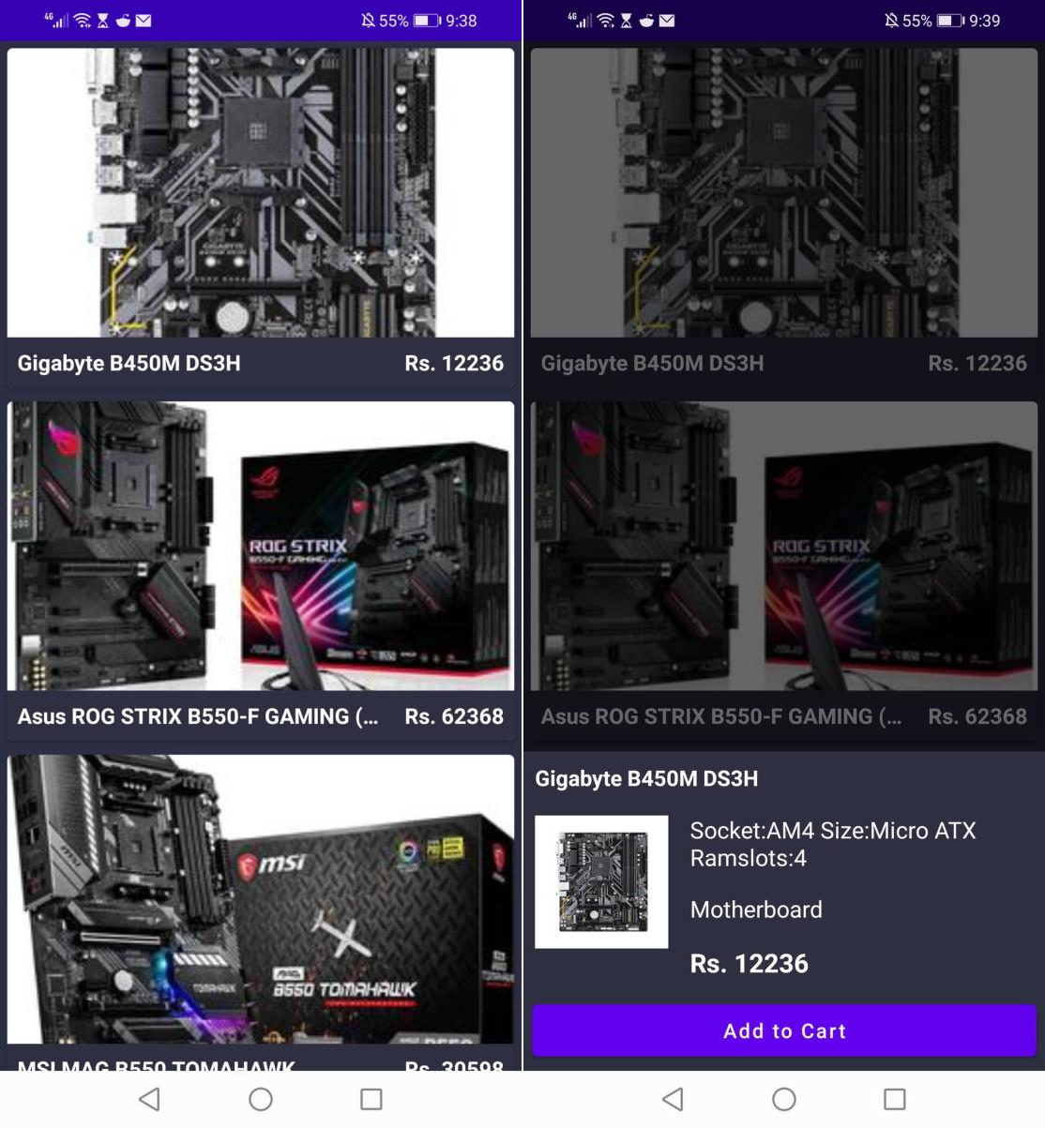

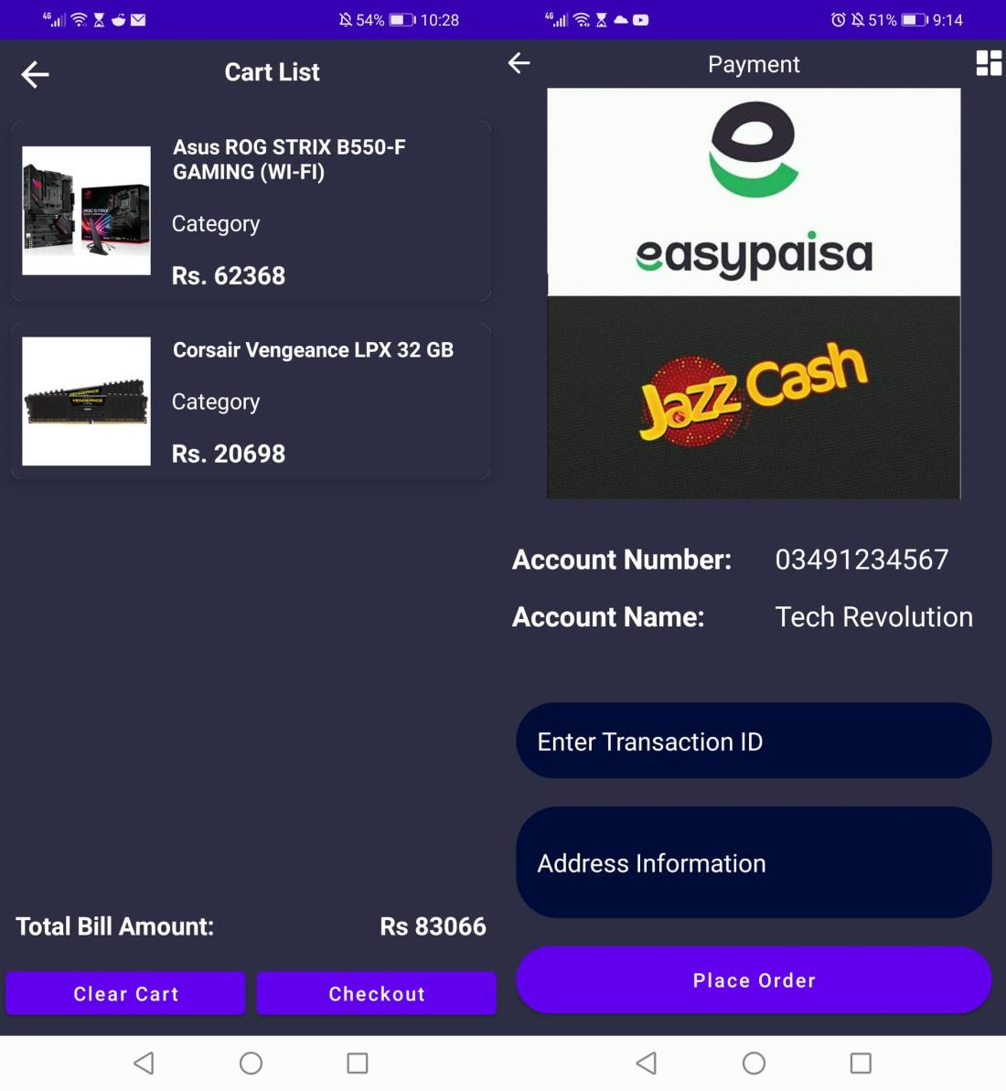

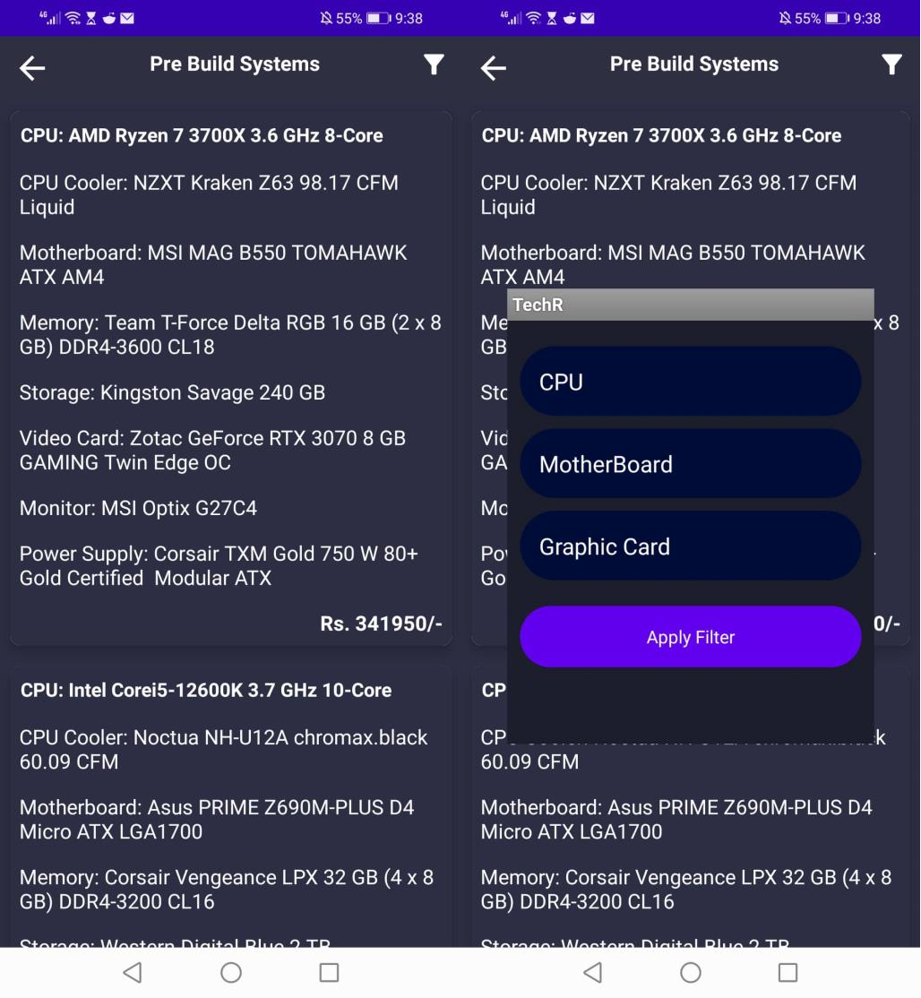

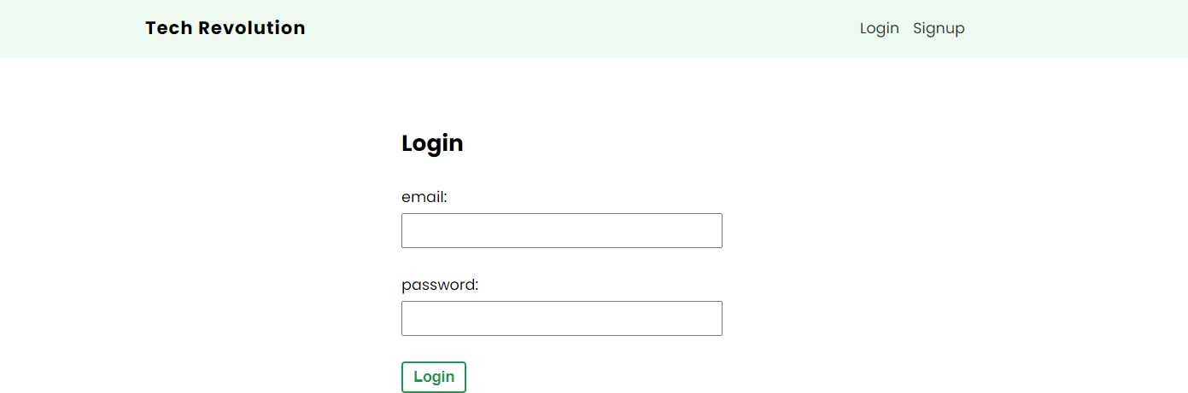

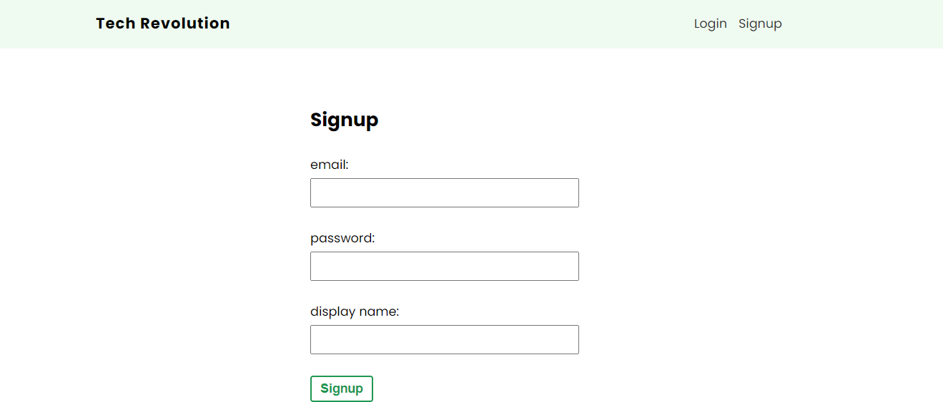

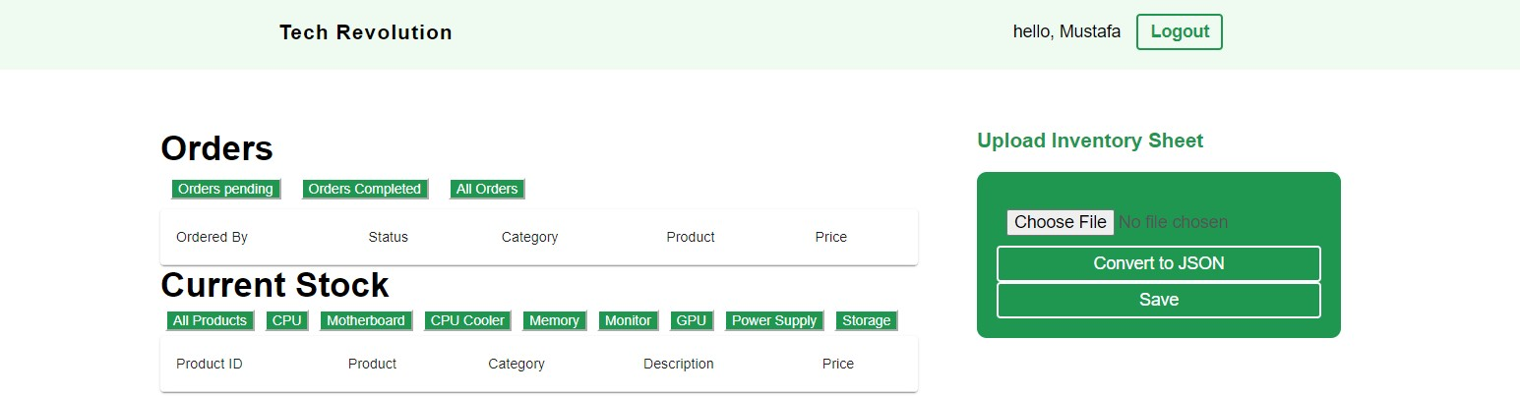

## Reuse and relationships to other products

Since the application is in the early phase of development therefore the reusable components haven’t been decided and implement yet. One component which will be implemented is the use of search bar as it will provide assistance to customer to search for specific category and then reuse that operation to search for specific product.

## Design decisions and tradeoffs

* 1. The design decision to separate inventory management from the main database has ensured encapsulation in terms of adding or altering data entities. The main item inventory of Tech Revolution is secured on the Firebase platform while the web server provides an individual space for vendors to manage their stock. In simple words, there would be no need to access the required data by using the same path by reference.
  2. The idea to implement multiple linked screens has ensured maximum readability. The use of bold yet simple color designs represent a user-friendly and interactive interface making it easy for us to switch between different functionalities. One of the major design decision involved is the use of the simple SETONCLICKLISTENER function that links different screens on the Tech Revolution application. This has made it easy to change screens without changing any functionalities within the app interface.
  3. An additional plus point is the use of different colored buttons that somehow provide the user with a descriptive view of different access points which ultimately makes the app easy to navigate and use.
  4. Furthermore, one of the most significant tradeoff involved is that the dataset of computer parts is collected and prepared from product list of last 5 years. This ultimately makes the recommended builds more functional and light for the consumer.

## Pseudo code for components

Each provided screen structure must have the following methodologies:

* A button or text link to move screens forward and backward simultaneously.
* Easily accessible and descriptive screens
* User authentication process after successful execution moves to Customer/Merchant Dashboard
* Search Product component communicates to Merchant’s Inventory component to browse products.
* Cart component is accessed when Customer reaches to Orders component.

## Appendices

### Class Diagram:

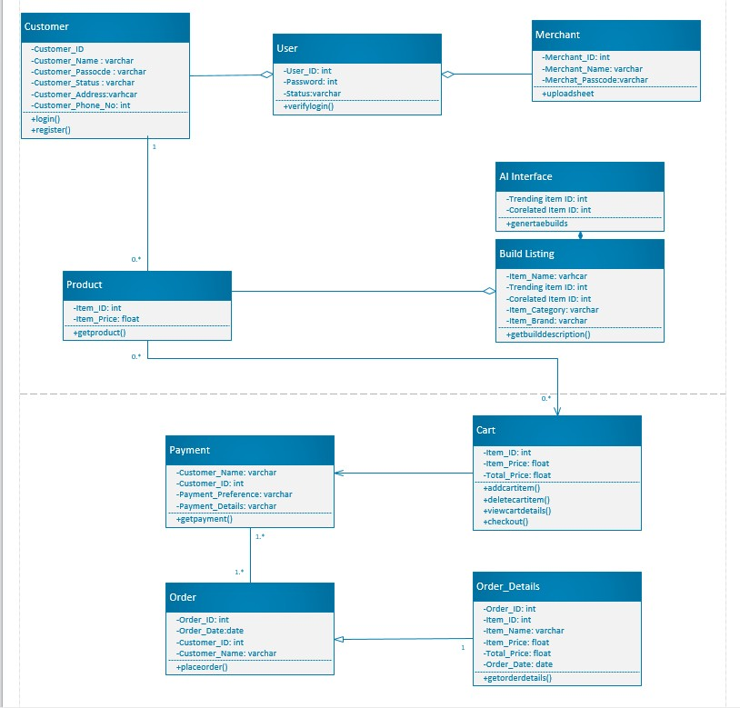

### 8.2 Object Diagram:

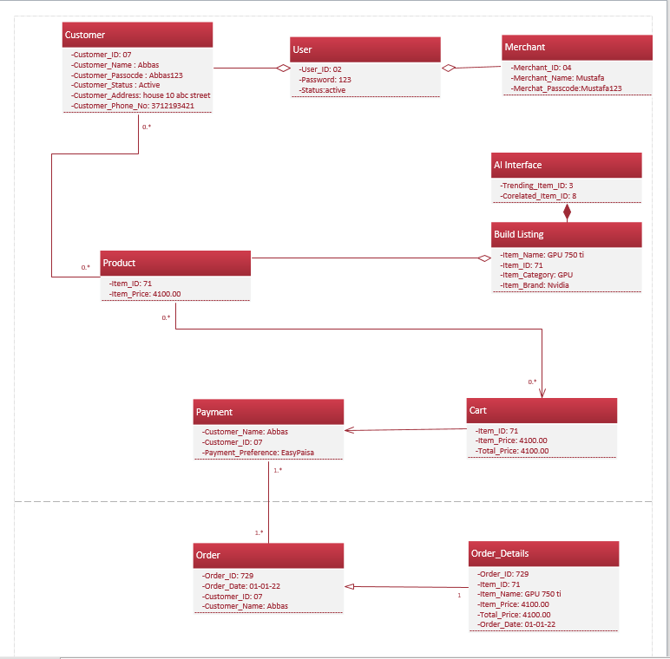

### 8.3 Statechart Diagram:

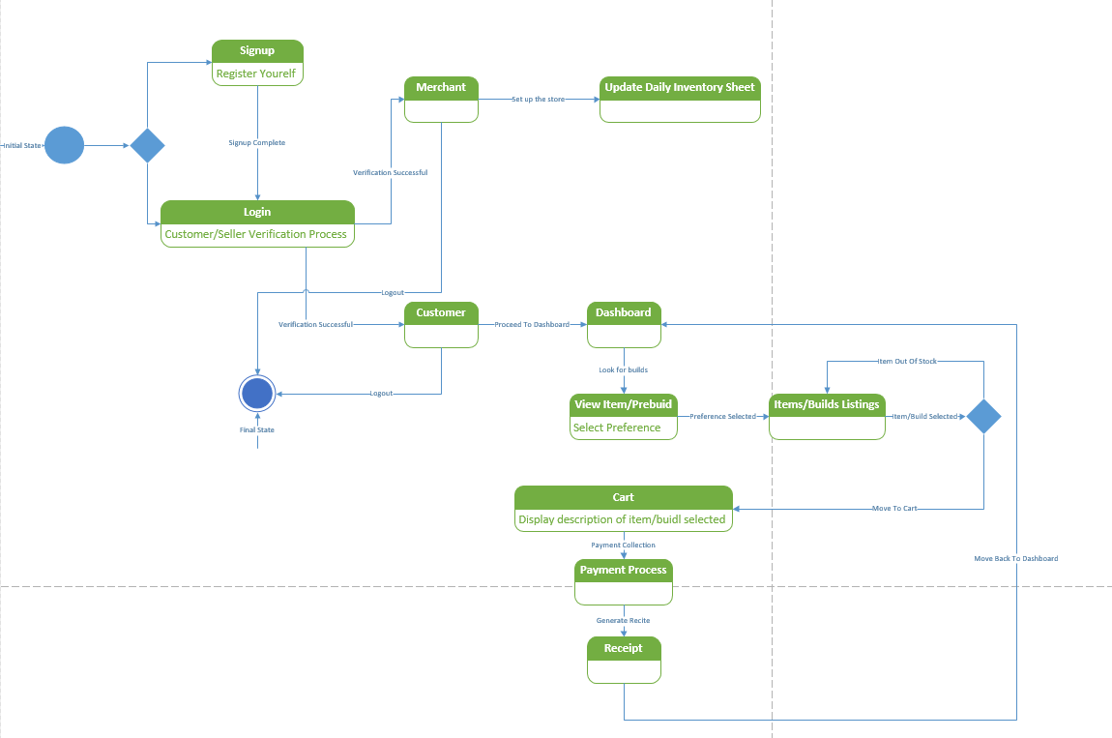

### 8.4 Activity Diagrams:

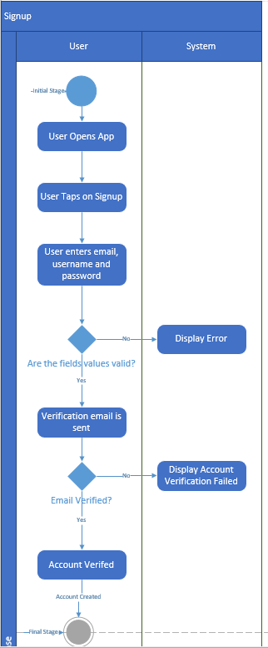

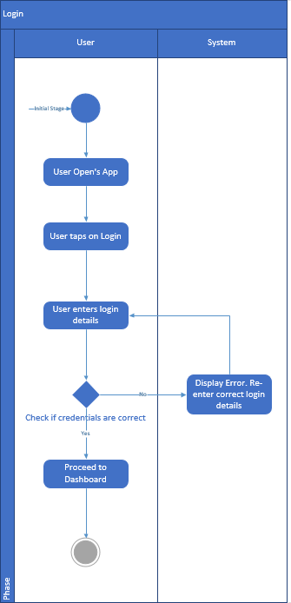

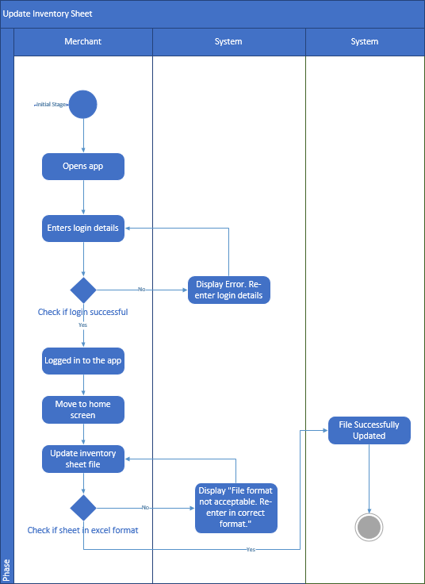

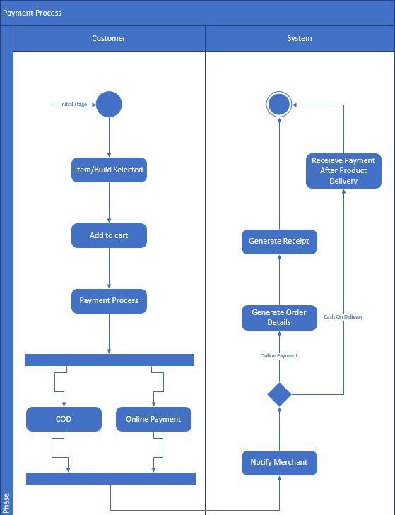

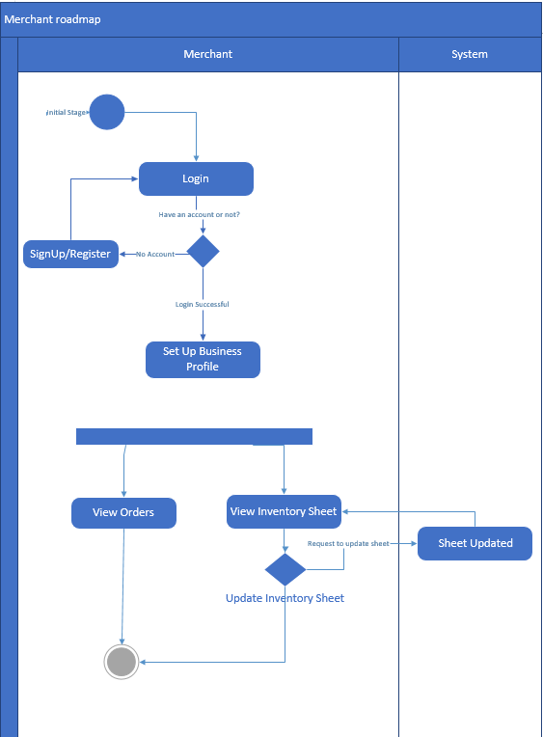

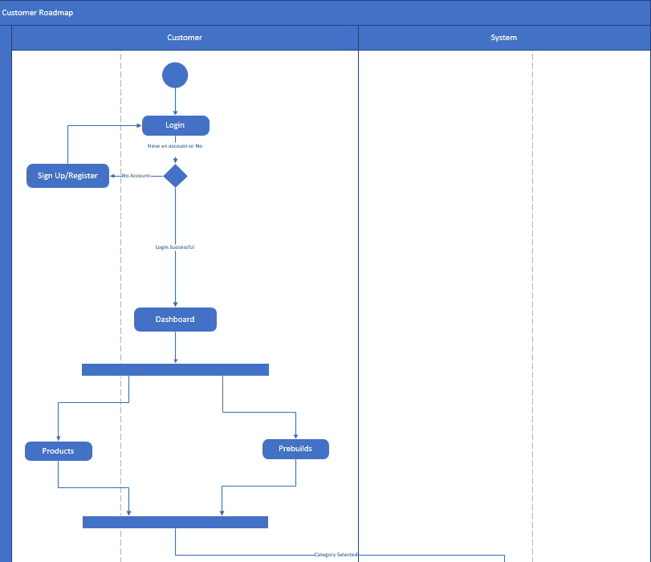

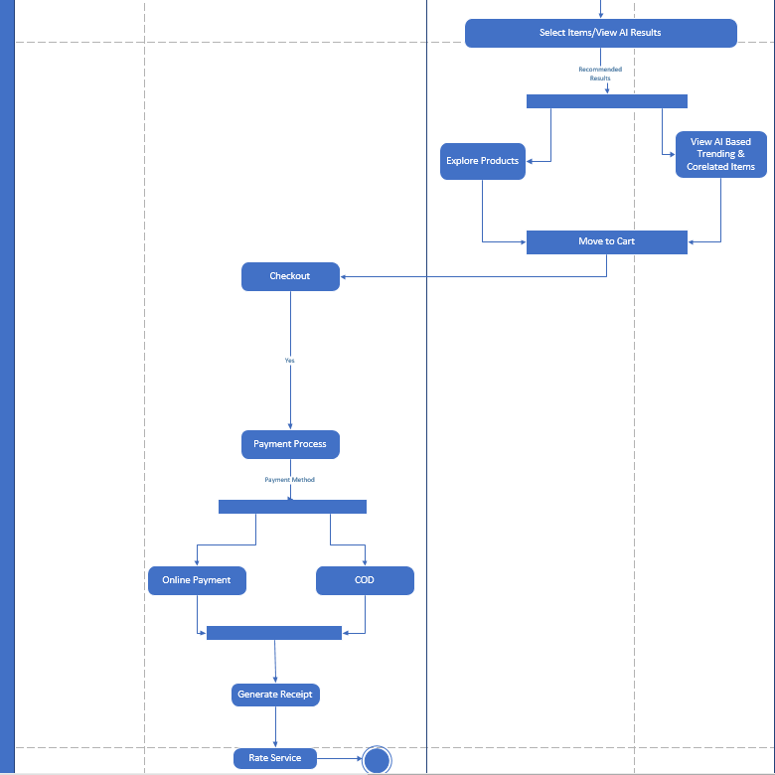

### 8.5 Sequence Diagram:

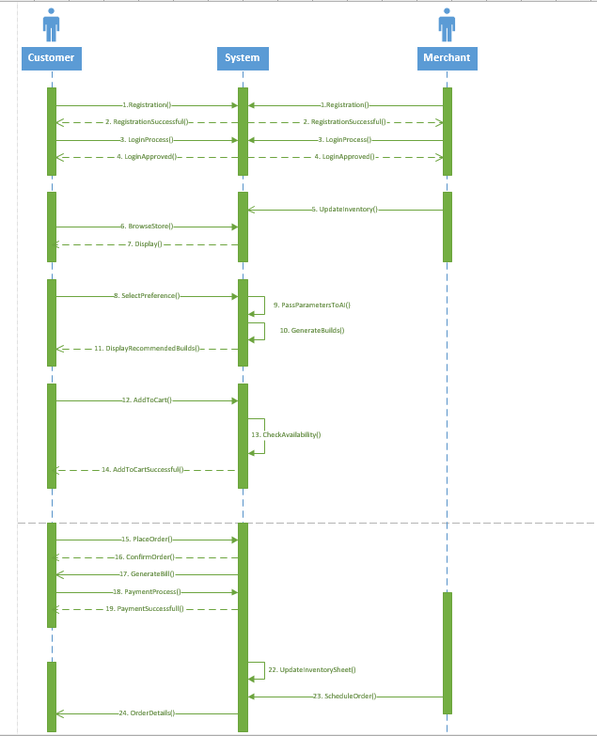

### 8.6 Collaboration Diagram:

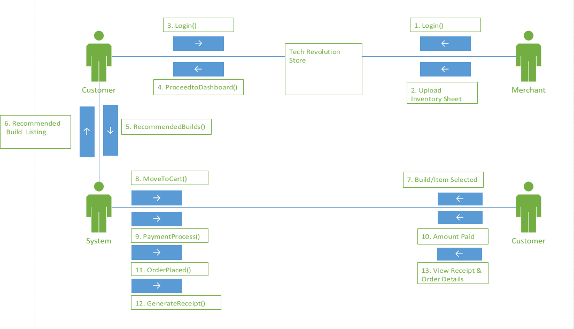

### 8.7 Use-Case Diagram:



### 8.8 Component Diagram:

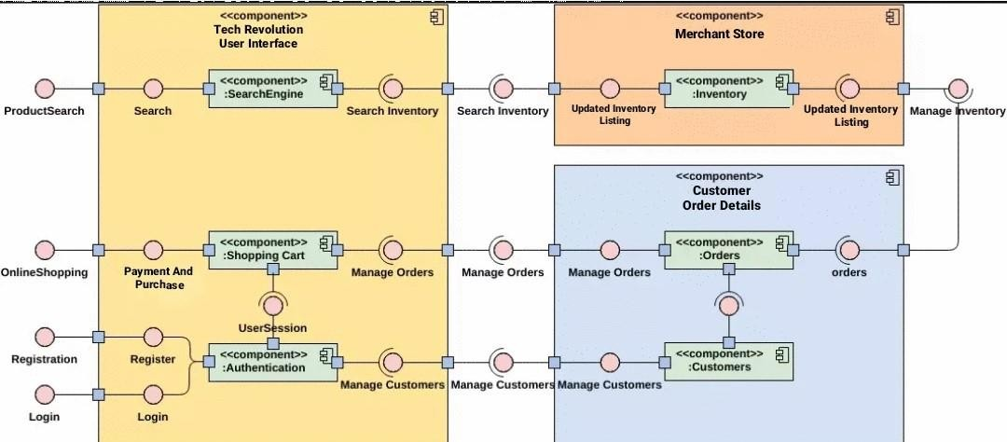

### 8.9 Deployment Diagram:

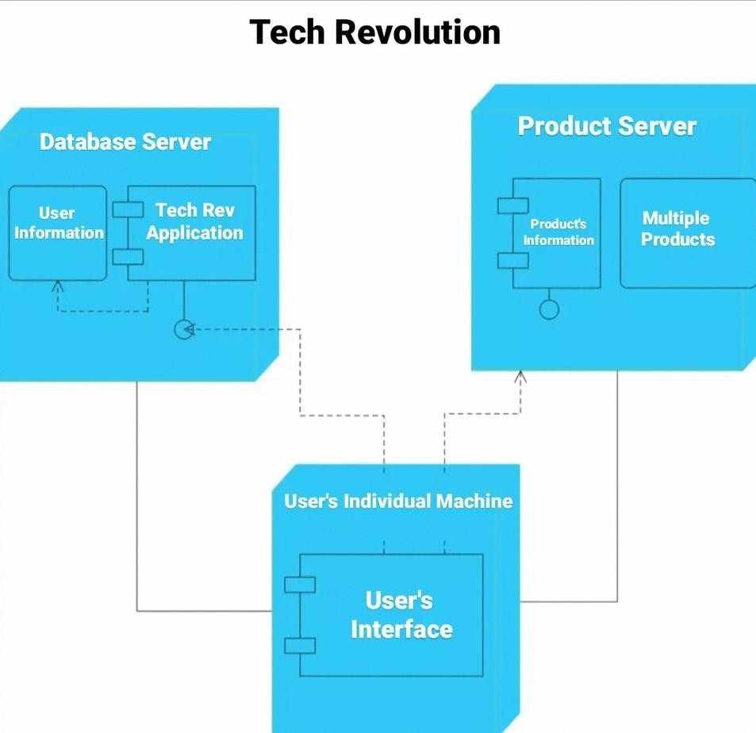

**Test Cases**

**For**

**Tech Revolution**

**Version 1.0 approved**

**Prepared by**

**Ghulam Mustafa 1812263**

**Muhammad Abbas Safdar 1812268**

**SZABIST**

**June 20th, 2022**

# Test Cases

## Test Case 1: Customer Login

|  |  |  |  |  |  |  |
| --- | --- | --- | --- | --- | --- | --- |
| **Test**  **Case ID** | **Test Case Name** | **Test Case Summary** | **Test Case Steps** | **Expected Result** | **Actual Result** | **Pass/Fail** |
| 1. | Login as Customer | Testing customer login functionality. | 1.Enter Email Address 2.Enter Password  3. Press Login | 1.Login Successful. Show Home Screen. | 1.Login Successful Show Home Screen | PASS |
| 2. | Security Verification | Login Attempt with correct email address but incorrect password. | 1. Enter correct email address. 2. Enter incorrect password. 3. Press Login. | 1. Login unsuccessful. 2.Incorrect credentials error message shown. | 1. Login unsuccessful. 2.Incorrect credentials error message shown. | PASS |
| 3. | Security Verification | Login Attempt with incorrect email address but correct password. | 1. Enter incorrect email address. 2. Enter correct password 3. Press Login. | 1. Login unsuccessful. 2.Incorrect credentials error message shown. | 1. Login unsuccessful. 2.Incorrect credentials error message shown. | PASS |

## Test Case 2: Customer Sign Up

|  |  |  |  |  |  |  |
| --- | --- | --- | --- | --- | --- | --- |
| **Test Case ID** | **Test Case Name** | **Test Case Summary** | **Test Case Steps** | **Expected Result** | **Actual Result** | **Pass/Fail** |
| 1. | Sign up as Customer | Testing customer sign up functionality. | 1.Enter Email Address 2.Enter verification code 3.Enter Password  3. Press Sign Up | 1.Sign up Successful. Show Login Screen. | 1.Sign up Successful Show Login Screen | PASS |
| 2. | Security Verification | Sign up Attempt with correct email address but incorrect password. | 1. Enter correct email address. 2. Enter incorrect password. 3. Press Sign up. | 1. Sign up unsuccessful. 2.Incorrect credentials error message shown. | 1. Sign up unsuccessful. 2.Incorrect credentials error message shown. | PASS |
| 3. | Security Verification | Sign up Attempt with incorrect email address but correct password. | 1. Enter incorrect email address. 2. Enter correct password 3. Press Sign up. | 1. Sign up unsuccessful. 2.Incorrect credentials error message shown. | 1. Sign up unsuccessful. 2.Incorrect credentials error message shown. | PASS |

## Test Case 3: Customer Authentication

|  |  |  |  |  |  |  |
| --- | --- | --- | --- | --- | --- | --- |
| **Test Case ID** | **Test Case Name** | **Test Case Summary** | **Test Case Steps** | **Expected Result** | **Actual Result** | **Pass/Fail** |
| 1. | To load profile | Testing Customer to see if their data is fetched from the database successfully. | 1. Customer taps on Login. 2. The customer email is looked up in the database for existing details. 3. Customer name, number and other details are fetched and customer dashboard is displayed with fields of name, address and email   prefetched. | Customer is able to see his details on the dashboard screen. | Customer is able to see his details on the dashboard screen. | PASS |

## Test Case 4: Customer Edit Profile

|  |  |  |  |  |  |  |
| --- | --- | --- | --- | --- | --- | --- |
| **Test Case ID** | **Test Case Name** | **Test Case Summary** | **Test Case Steps** | **Expected Result** | **Actual Result** | **Pass/Fail** |
| 1. | To edit profile | Testing Customer to see if he/she can use edit profile functionality. | 1.Customer taps on field that he/she wish to edit and update information 2.Customer taps on save changes to update the fields  3. The profile is displayed with the updated  information | Customer is able to edit his/her profile. | Customer is able to edit his/her profile. | PASS |

## Test Case 5: Add to Cart

|  |  |  |  |  |  |  |
| --- | --- | --- | --- | --- | --- | --- |
| **Test Case ID** | **Test Case Name** | **Test Case Summary** | **Test Case Steps** | **Expected Result** | **Actual Result** | **Pass/Fail** |
| 1. | To add a product to cart. | Testing if Customer can add a product to their cart. | 1.Customer browse the store to view available products 2.Customer selects a product and press add to cart button  3. The product name along with price  is displayed in the cart | Customer is able to add a product to cart successfully | Customer is able to add a product to cart successfully | PASS |

## Test Case 6: Remove from Cart

|  |  |  |  |  |  |  |
| --- | --- | --- | --- | --- | --- | --- |
| **Test Case ID** | **Test Case Name** | **Test Case Summary** | **Test Case Steps** | **Expected Result** | **Actual Result** | **Pass/Fail** |
| 1. | To remove a product from cart. | Testing if Customer can remove a product from their cart. | 1. Customer is directed to the checkout screen. 2. The product name along with price is displayed in the cart list 3. Customer presses the remove button to remove an item from   cart list. | Customer is able to remove a product from cart successfully | Customer is able to remove a product from cart successfully | PASS |

## Test Case 7: Proceed to checkout

|  |  |  |  |  |  |  |
| --- | --- | --- | --- | --- | --- | --- |
| **Test Case**  **ID** | **Test Case Name** | **Test Case Summary** | **Test Case Steps** | **Expected Result** | **Actual Result** | **Pass/Fail** |
| 1. | To proceed to checkout | Testing if Customer can initiate order request. | 1.Customer views the products in his cart 2.Customer selects Proceed to checkout button  3. An order request is  initiated. | Customer is directed to Payment Process Screen | Customer is directed to Payment Process Screen | PASS |

## Test Case 8: Select Payment Method

|  |  |  |  |  |  |  |
| --- | --- | --- | --- | --- | --- | --- |
| **Test**  **Case ID** | **Test Case Name** | **Test Case Summary** | **Test Case Steps** | **Expected Result** | **Actual Result** | **Pass/Fail** |
| 1. | To select payment method | Testing if Customer can browse the available payment methods. | 1. Customer is directed to payment process screen. 2. Customer selects choose payment method   button | Customer is displayed with the available payment methods | Customer is displayed with the available payment methods | PASS |

## Test Case 9: Place Order

|  |  |  |  |  |  |  |
| --- | --- | --- | --- | --- | --- | --- |
| **Test**  **Case ID** | **Test Case Name** | **Test Case Summary** | **Test Case Steps** | **Expected Result** | **Actual Result** | **Pass/Fail** |
| 1. | To Place Order | Testing if Customer can place order successfully | 1.Customer is directed to payment process screen. 2.Customer goes through the billing process and  3. Press place order | Customer is directed to order successful screen | Customer is directed to order successful screen | PASS |

## Test Case 10: Top Trending Products

|  |  |  |  |  |  |  |
| --- | --- | --- | --- | --- | --- | --- |
| **Test Case ID** | **Test Case Name** | **Test Case Summary** | **Test Case Steps** | **Expected Result** | **Actual Result** | **Pass/Fail** |
| 1. | Top Trending Products | Checking the top trending products | 1. Customer moves to recommend systems/parts. 2. Tap on top trending products 3. Customer views the result | The top trending products are displayed to the customer | The top trending products are displayed to the customer | PASS |

## Test Case 11: Products Correlation

|  |  |  |  |  |  |  |
| --- | --- | --- | --- | --- | --- | --- |
| **Test**  **Case ID** | **Test Case Name** | **Test Case Summary** | **Test Case Steps** | **Expected Result** | **Actual Result** | **Pass/Fail** |
| 1. | Products Correlation | Testing the products correlation phase | 1. Customer selects a particular product and looks for related parts 2. Customer views correlated products 3. Customer moves   forward | Correlated parts to be displayed. | Correlated parts are displayed. | PASS |

## Test Case 12: PreBuild Systems (Advanced Filtering Feature)

|  |  |  |  |  |  |  |
| --- | --- | --- | --- | --- | --- | --- |
| **Test Case ID** | **Test Case Name** | **Test Case Summary** | **Test Case Steps** | **Expected Result** | **Actual Result** | **Pass/Fail** |
| 1. | PreBuild System | Provide builds based on filtering options. | 1. Customer is provided with a list of builds, these builds are based on compatibility of components. 2. Customer can apply filters on CPU, Motherboard and Graphics Card 3. Customer   presses apply filter button | A new list of builds is displayed based on applied filters | A new list of builds is displayed based on applied filters. | PASS |

## Test Case 13: Merchant Sign Up

|  |  |  |  |  |  |  |
| --- | --- | --- | --- | --- | --- | --- |
| **Test Case ID** | **Test Case Name** | **Test Case Summary** | **Test Case Steps** | **Expected Result** | **Actual Result** | **Pass/Fail** |
| 1. | Sign up as Merchant | Testing Merchant sign up functionality. | 1. Enter Email Address 2.Enter Password 3.Enter Name  3. Press Sign Up | 1. Sign up Successful. Show Login Screen. | 1.Sign up Successful Show Login Screen | PASS |
| 2. | Security Verification | Sign up Attempt with correct email address but incorrect password. | 1. Enter correct email address. 2. Enter incorrect password. 3. Press Sign up. | 1. Sign up unsuccessful. 2. Incorrect credentials error message shown. | 1. Sign up unsuccessful. 2. Incorrect credentials error message shown. | PASS |
| 3. | Security Verification | Sign up Attempt with incorrect email address but correct password. | 1. Enter incorrect email address. 2. Enter correct password 3. Press Sign up. | 1. Sign up unsuccessful. 2. Incorrect credentials error message shown. | 1. Sign up unsuccessful. 2. Incorrect credentials error message shown. | PASS |

## Test Case 14: Merchant Login

|  |  |  |  |  |  |  |
| --- | --- | --- | --- | --- | --- | --- |
| **Test Case ID** | **Test Case Name** | **Test Case Summary** | **Test Case Steps** | **Expected Result** | **Actual Result** | **Pass/Fail** |
| 1. | Login as Merchant | Testing Merchant login functionality. | 1.Enter Email Address 2.Enter Password  3. Press Login | 1. Login Successful. Show Merchant dashboard. | 1.Login Successful Show Merchant dashboard |  |
| 2. | Security Verification | Login Attempt with correct email address but incorrect password. | 1. Enter correct email address. 2. Enter incorrect password. 3. Press Login. | 1. Login unsuccessful. 2. Incorrect credentials error message shown. | 1. Login unsuccessful. 2. Incorrect credentials error message shown. |  |
| 3. | Security Verification | Login Attempt with incorrect email address but correct password. | 1. Enter incorrect email address. 2. Enter correct password 3. Press Login. | 1. Login unsuccessful. 2. Incorrect credentials error message shown. | 1. Login unsuccessful. 2. Incorrect credentials error message shown. |  |

## Test Case 15: Upload Inventory Sheet

|  |  |  |  |  |  |  |
| --- | --- | --- | --- | --- | --- | --- |
| **Test Case ID** | **Test Case Name** | **Test Case Summary** | **Test Case Steps** | **Expected Result** | **Actual Result** | **Pass/Fail** |
| 1. | Upload Inventory Sheet | Uploading Merchant Inventory Sheet | 1. Login to the portal 2. Press on upload inventory file button 3. Locate File | 1. Login Successful. Show Merchant dashboard. | 1.Login Successful Show Merchant dashboard | PASS |
| 2. | Convert file to JSON | Convert uploaded file into JSON in order to meet  database requirement | 1. Upload the file 2. Click on convert to JSON 3. Click on Save | File successfully converted to JSON. | File successfully converted to JSON. | PASS |
| 3. | Pass inventory data to Firestore | Pass the inventory sheet data to Firestore | 1. Click on the save button to move data to Firestore. | Data successfully transferred to Firestore | Data successfully transferred to Firestore | PASS |

## Test Case 16: View Orders

|  |  |  |  |  |  |  |
| --- | --- | --- | --- | --- | --- | --- |
| **Test Case ID** | **Test Case Name** | **Test Case Summary** | **Test Case Steps** | **Expected Result** | **Actual Result** | **Pass/Fail** |
| 1. | View Orders | View Orders | 1. Login to the portal. 2. Move to orders section 3. View pending and completed   orders | Order sheet is displayed | Order sheet is displayed | PASS |

## Test Case 17: View Inventory (Filter option applied)

|  |  |  |  |  |  |  |
| --- | --- | --- | --- | --- | --- | --- |
| **Test Case**  **ID** | **Test Case Name** | **Test Case Summary** | **Test Case Steps** | **Expected Result** | **Actual Result** | **Pass/Fail** |
| 1. | View Inventory | View Inventory | 1. Login to the portal. 2. Move to inventory section 3. View the inventory section. 4. Press desired button to view inventory based on the button   selected. | Items list displayed with details. | Items list displayed with details. | PASS |

# USER MANUAL

**Android Application**

#### Access the application

1. Launch the application on your android device
2. Press “Let’s Get Started”

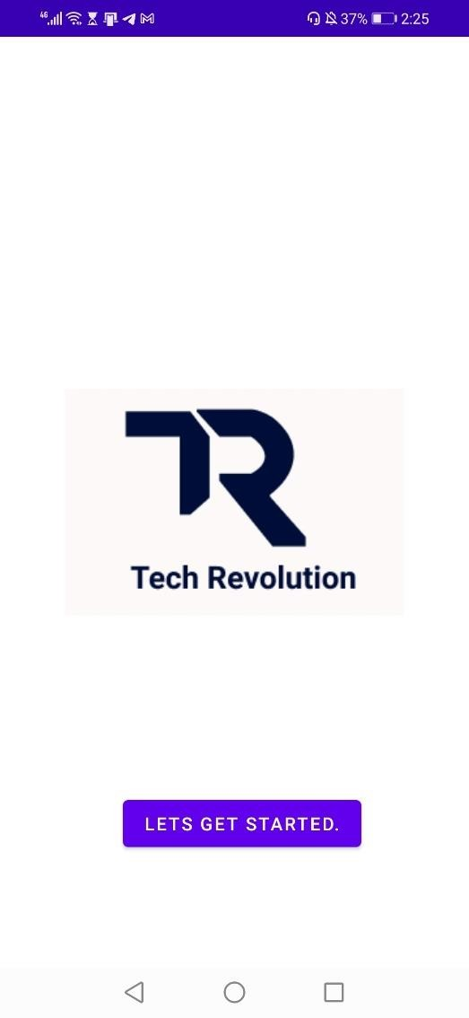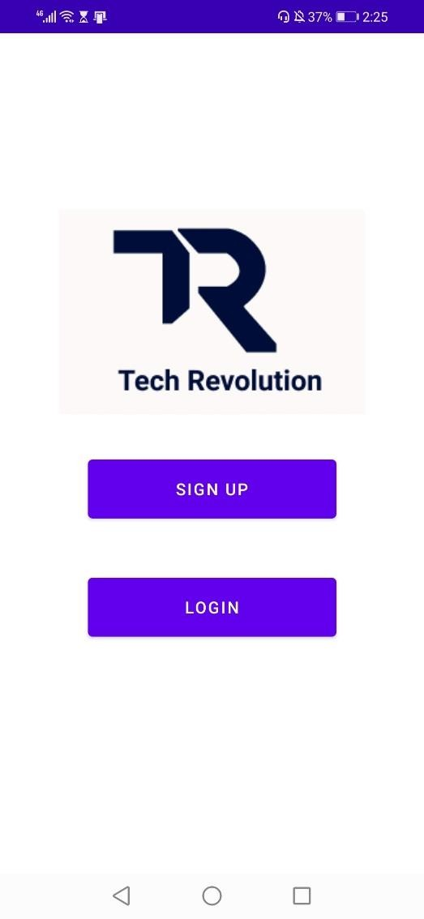

**SignUp/ Login**

1. Press Sign Up if you are new
2. Press Login if you already have an account

**Sign Up Process:**

1. Fill in the required details
2. Press Register once all correct details are provided
3. User will be prompt with error message if details provided are in incorrect format.

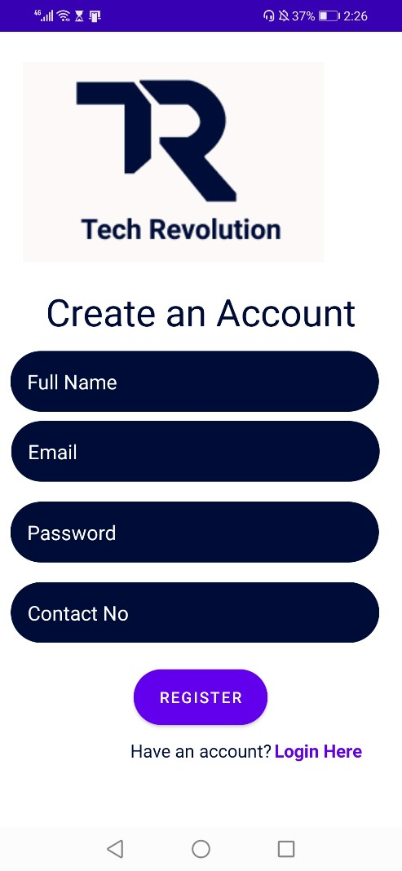

**Login Process:**

1. Enter your login credentials correctly
2. Press Login
3. User email and password will be authenticated and app will proceed to Dashboard screen

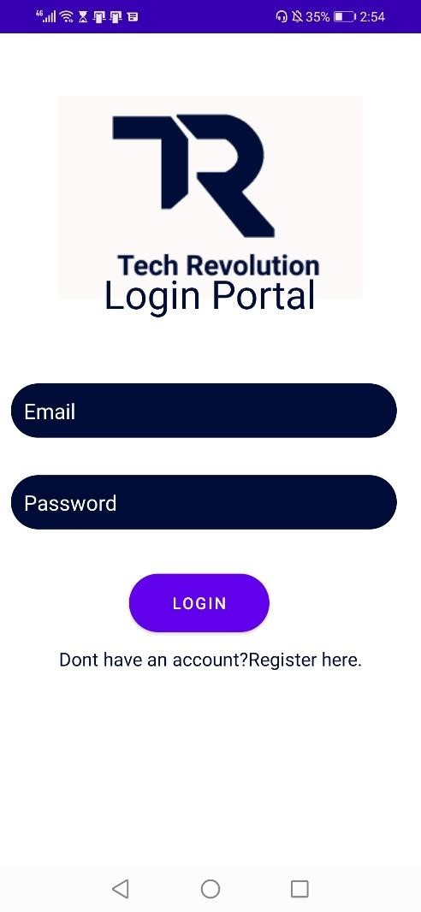

**User Dashboard:**

* 1. After authentication user details are fetched and displayed in application.
  2. User can browse through the application by clicking on the buttons displayed on screen
  3. User can logout by pressing the person icon displayed at the bottom of the screen.

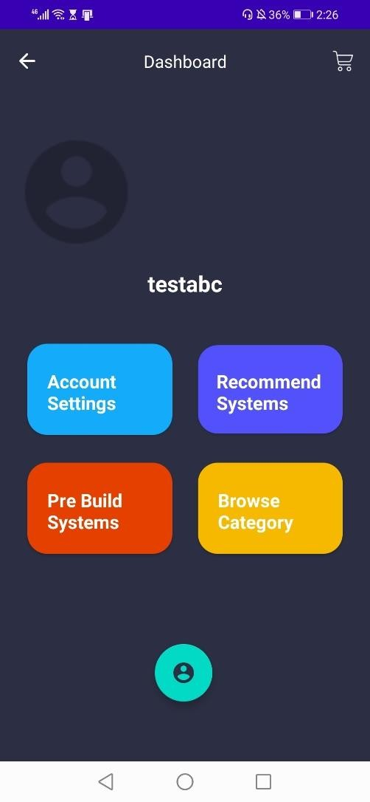

**Account Settings Screen:**

1. Press the Account Settings option on dashboard screen.
2. User profile details such as name, number and email are fetched from the database and displayed on screen.
3. 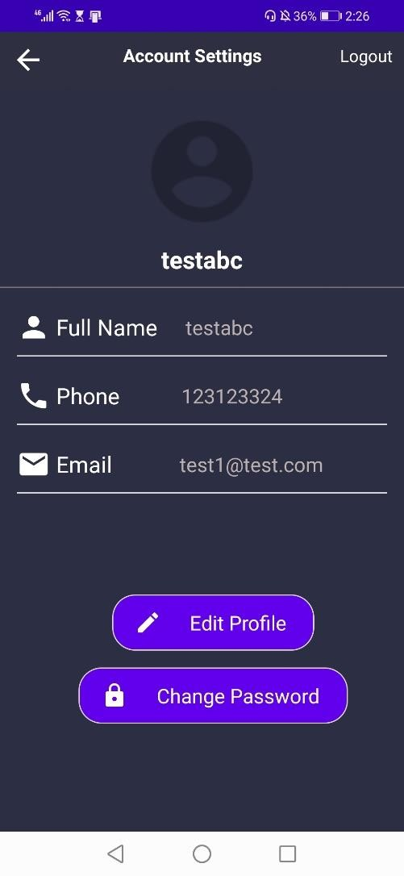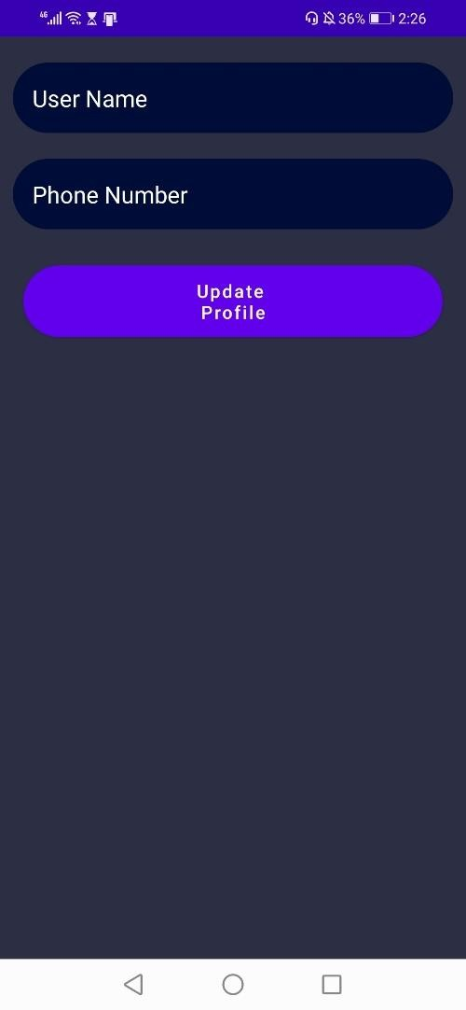There is an option to edit user profile which allows user to edit his name and contact number.
4. Update the details and press Update Profile to save your changes.
5. Press the back arrow on top left to go back to Dashboard Screen.

**Pre-Build Systems Option:**

* 1. Press Pre-Build System option on Dashboard Screen.
  2. You will be displayed with a list of system builds along with their configurations and total price for the complete system build.
  3. This makes it easier experience for people who are not experienced with what product is best compatible with one another.
  4. There is a filter option at the top right of the page.
  5. You can narrow down your search results by providing specific details like name of processor, graphic card and motherboard.
  6. Press Apply Filter and you will only see builds with the combination of the 3 components you added on filter.

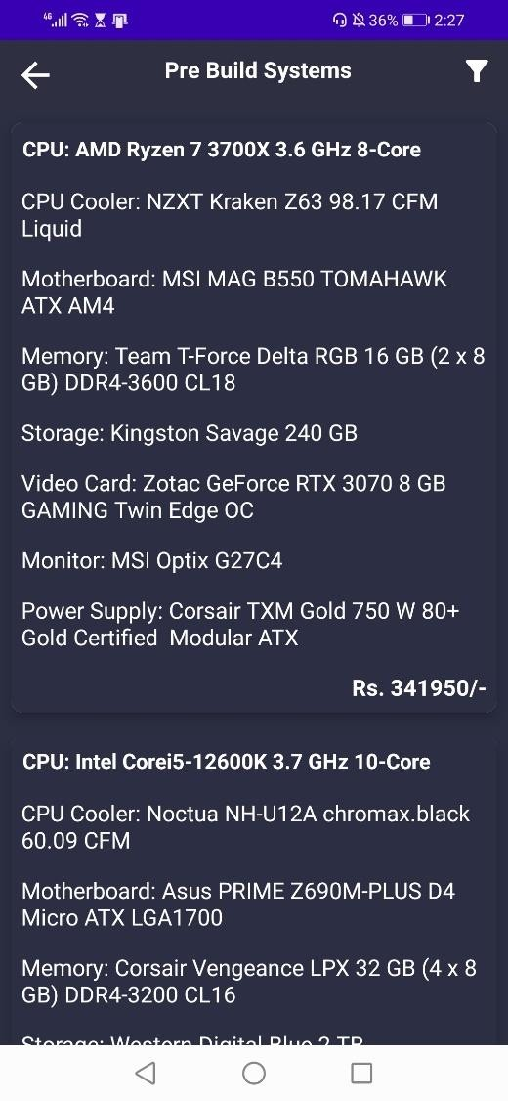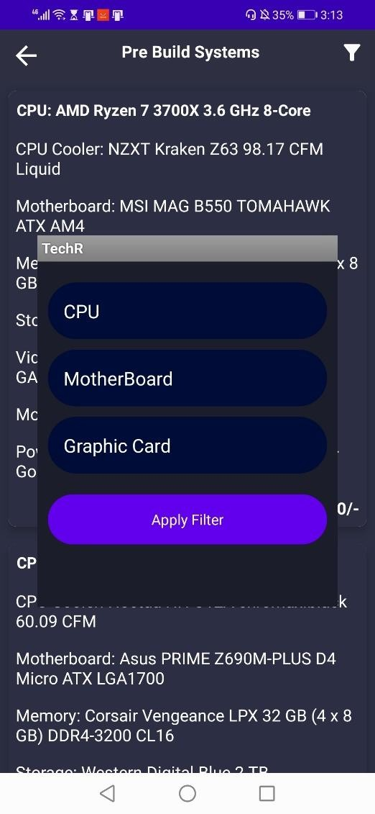

**Browse Category Option:**

1. Press Browse Category on the Dashboard Screen.
2. A list of categories will be displayed to the user.

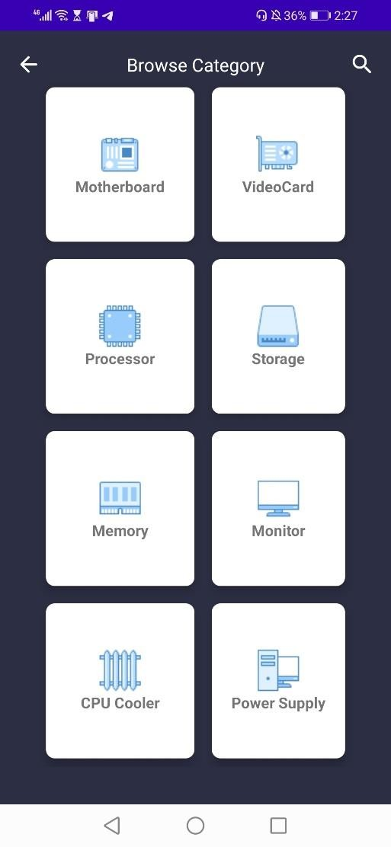

**Browse Motherboards:**

1. Select Motherboard Option in the Browse Category Screen
2. List of motherboards will be displayed along with their specification to the user.
3. Select motherboard of your choice and add it to your cart.

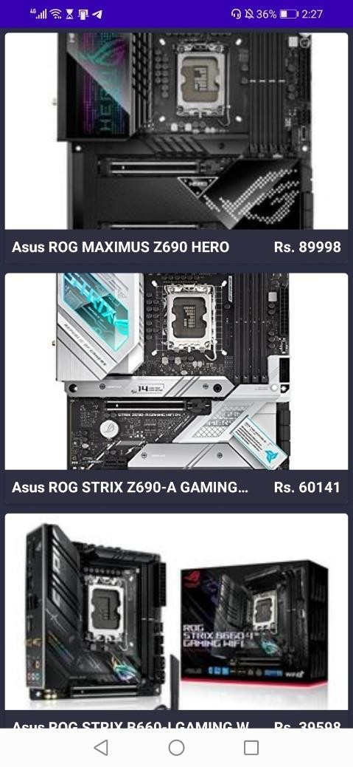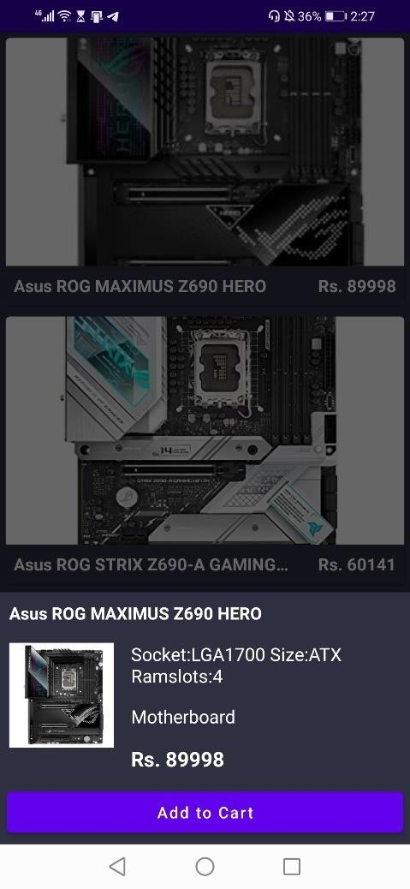

**Browse Video Card:**

1. Select Video Card Option in the Browse Category Screen
2. List of Video Cards will be displayed along with their specification to the user.
3. Select Video Card of your choice and add it to your cart.

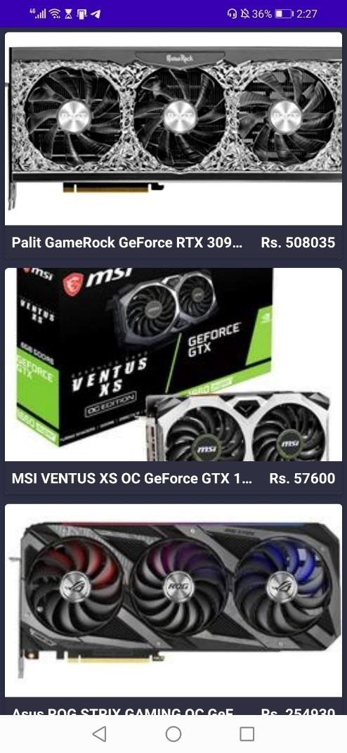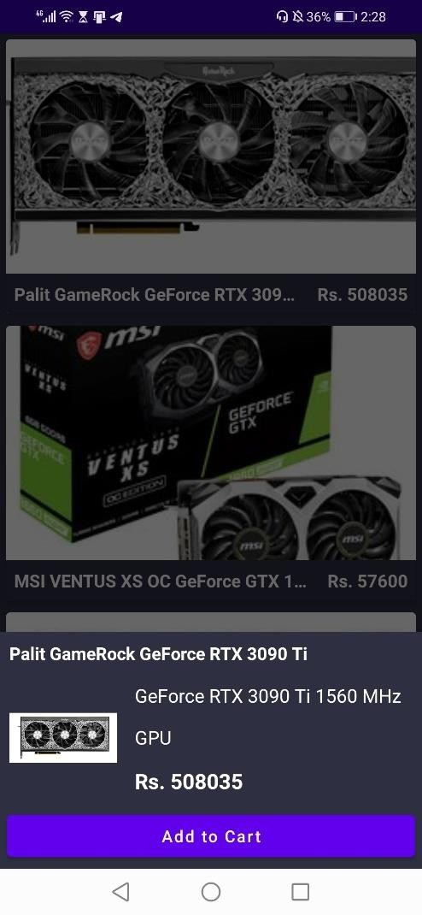

**Browse Processor:**

1. Select Processor Option in the Browse Category Screen
2. List of Processor will be displayed along with their specification to the user.
3. Select Processor of your choice and add it to your cart.

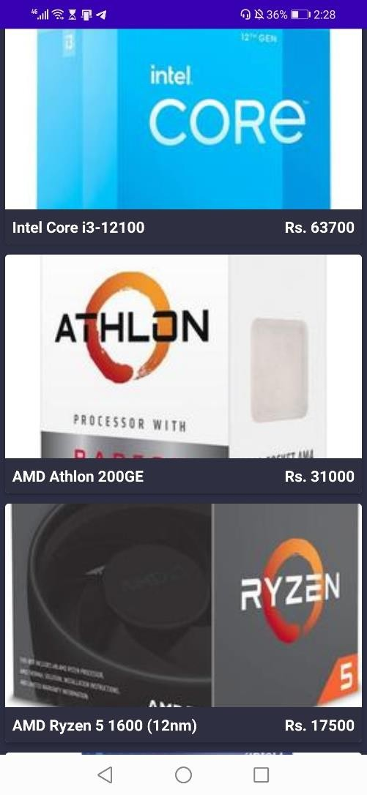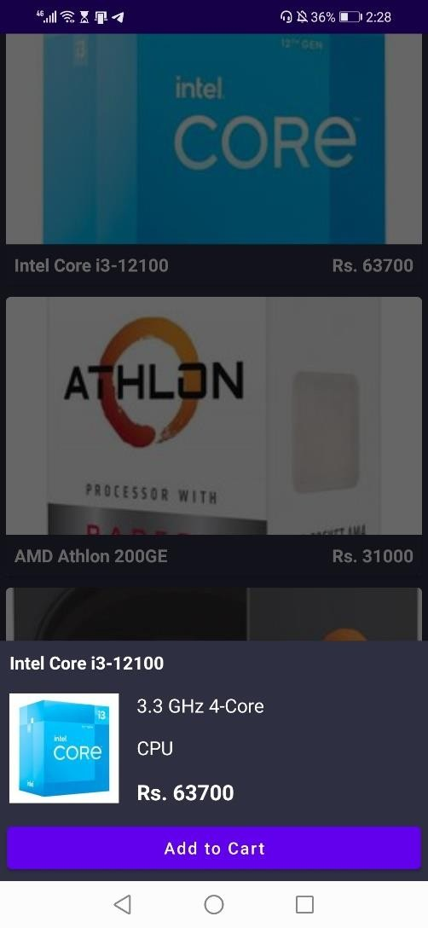

**Browse Storage:**

1. Select Storage Option in the Browse Category Screen
2. List of Storage will be displayed along with their specification to the user.
3. Select Storage of your choice and add it to your cart.

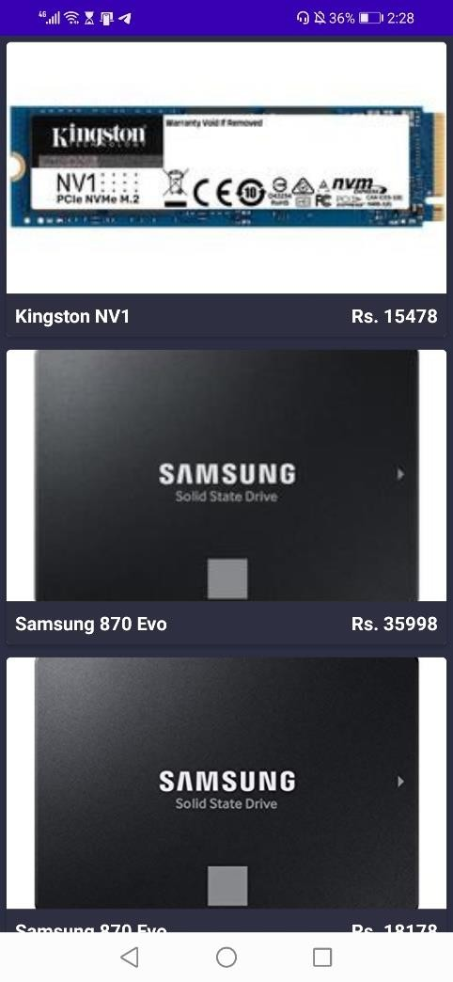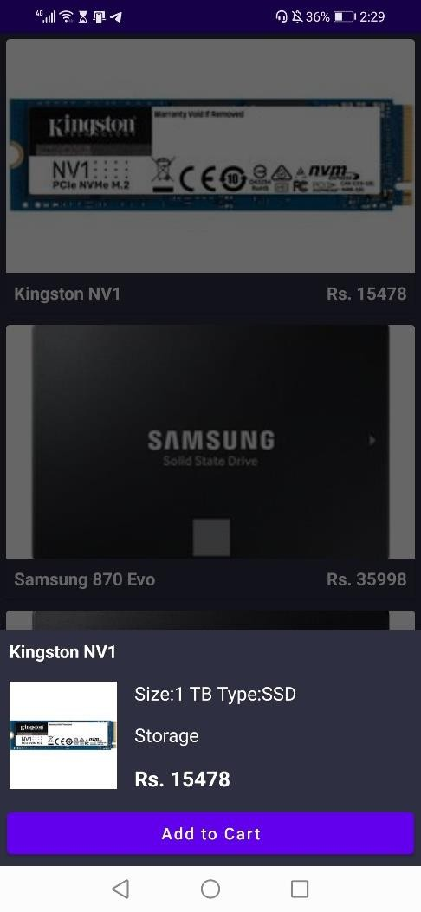

**Browse Memory:**

1. Select Memory Option in the Browse Category Screen
2. List of Memory will be displayed along with their specification to the user.
3. Select Memory of your choice and add it to your cart.

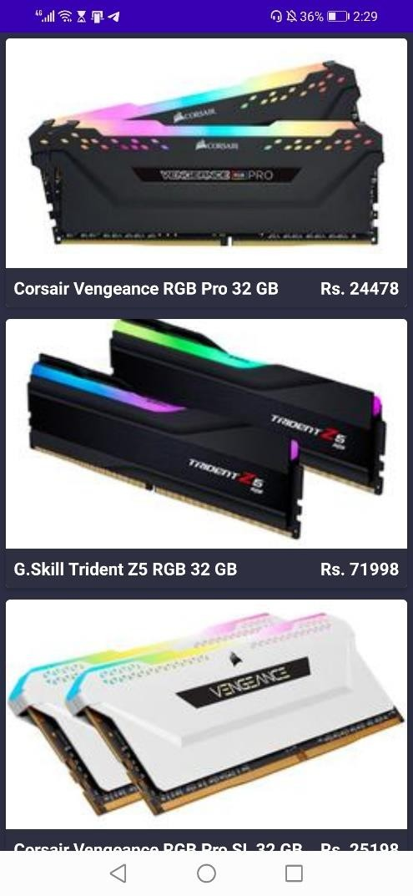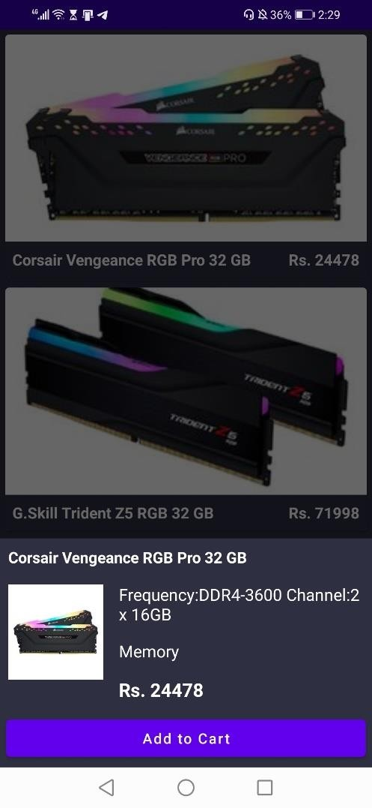

**Browse Monitor:**

1. Select Monitor Option in the Browse Category Screen
2. List of Monitor will be displayed along with their specification to the user.
3. Select Monitor of your choice and add it to your cart.

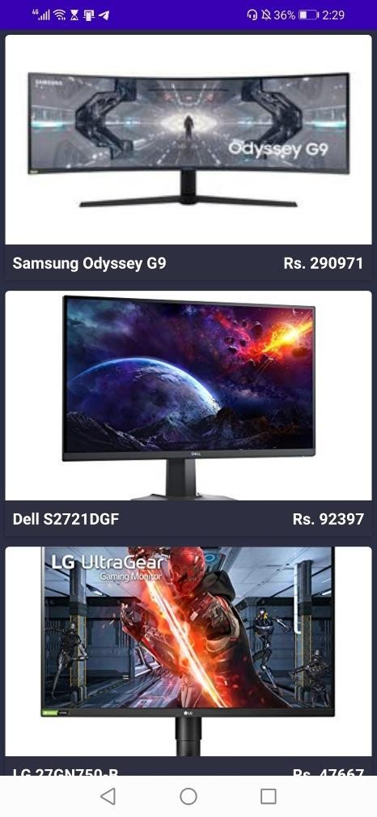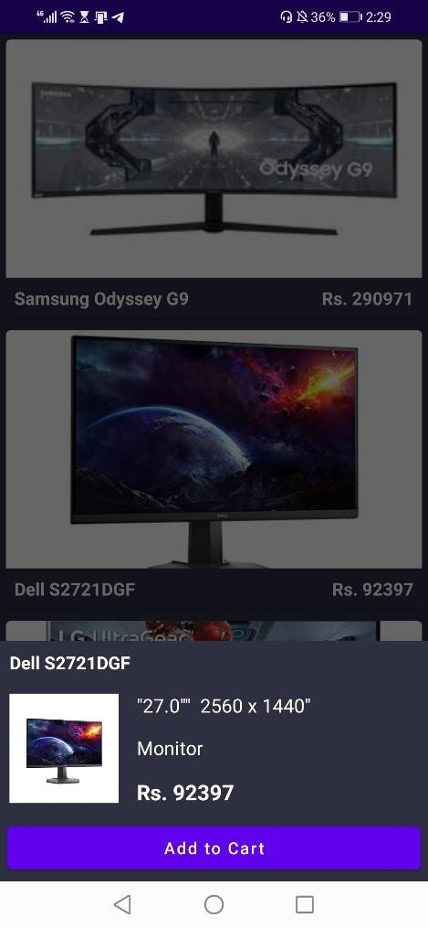

**Browse CPU Cooler:**

1. Select CPU Cooler Option in the Browse Category Screen
2. List of CPU Cooler will be displayed along with their specification to the user.
3. Select CPU Cooler of your choice and add it to your cart.

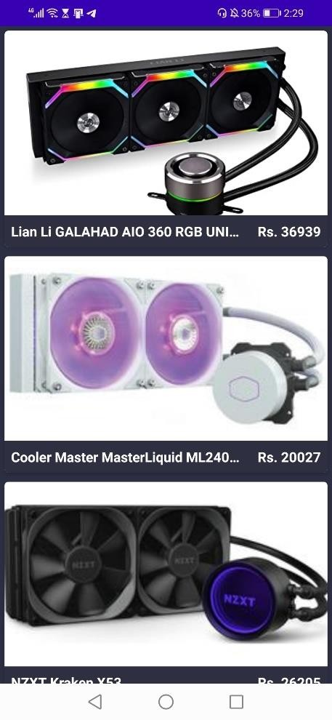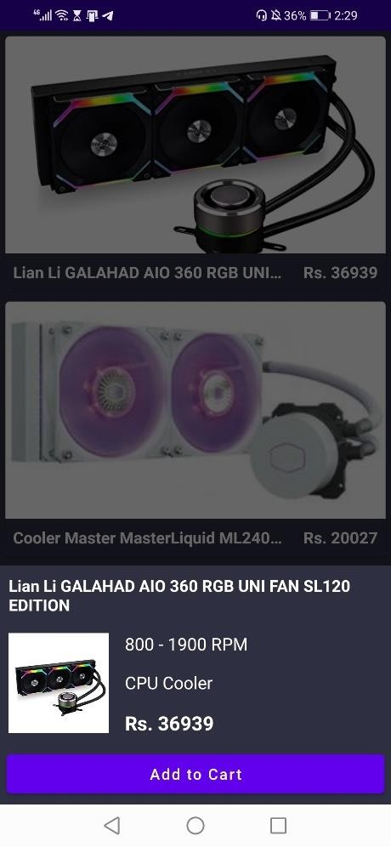

**Browse Power Supply:**

1. Select Power Supply Option in the Browse Category Screen
2. List of Power Supply will be displayed along with their specification to the user.
3. Select Power Supply of your choice and add it to your cart.

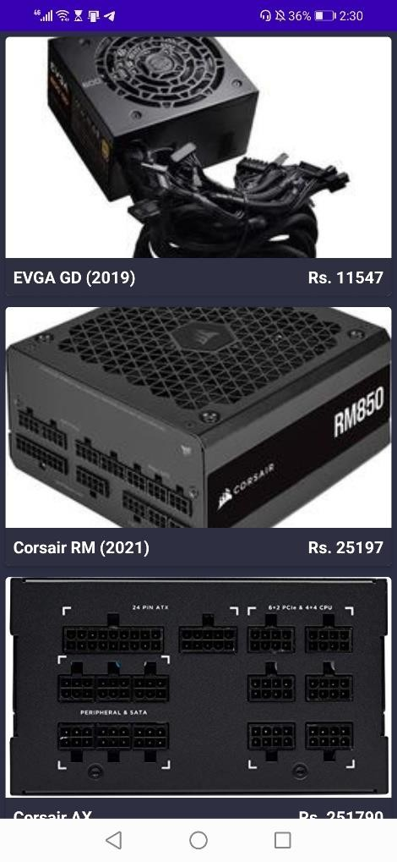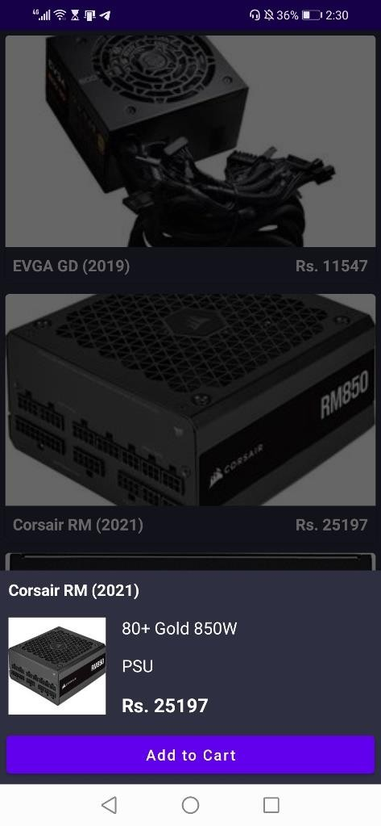

**Add to Cart Process:**

1. Press Add to Cart button to add product to your cart
2. User will be directed to cart list page where he can view the products of his cart and the individual component prices of each item present in his cart
3. A total bill amount is generated at the bottom right side of the screen to tell the user about his total bill amount so he can confirm and proceed to checkout
4. A clear cart option is also available to remove any products added and start over with a new configuration if the user makes a mistake with custom build.
5. The back arrow key is used to navigate back to Browse Category screen in case user wishes to add a new product.

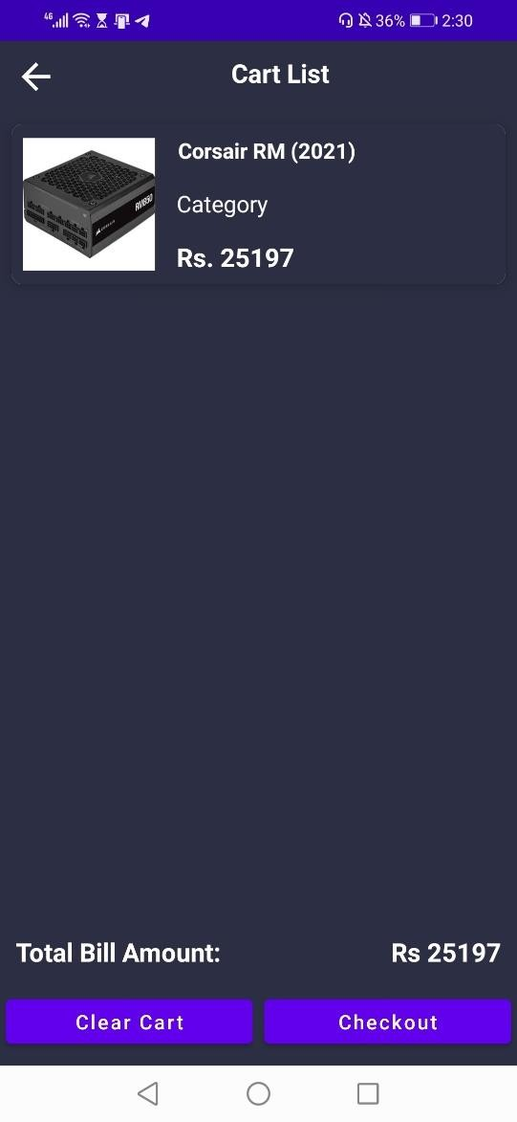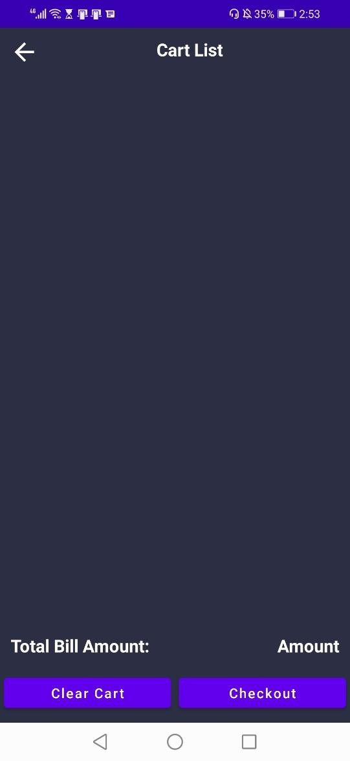

**Payment Process:**

1. Once you press the checkout button on Cart List Screen, user will be directed to Payment Screen.
2. Since the application is in its initial state that only payment options available are jazzcash/ easypaisa and the respective account details are displayed.
3. User must enter the transaction ID and Address information in order to complete the place order activity.
4. Validation checks are done on the address and transaction ID field to prevent from wrong inputs.
5. If you are not prompted with any error, press Place Order Button and your order will be place successfully.
6. User will be redirected to the dashboard screen and an order entry will be created on the backend database.

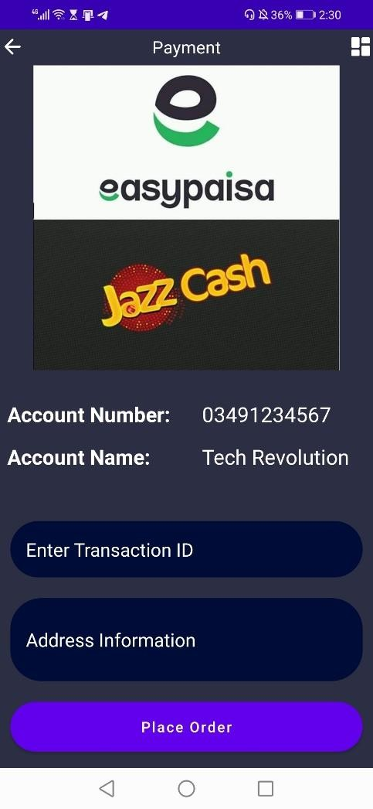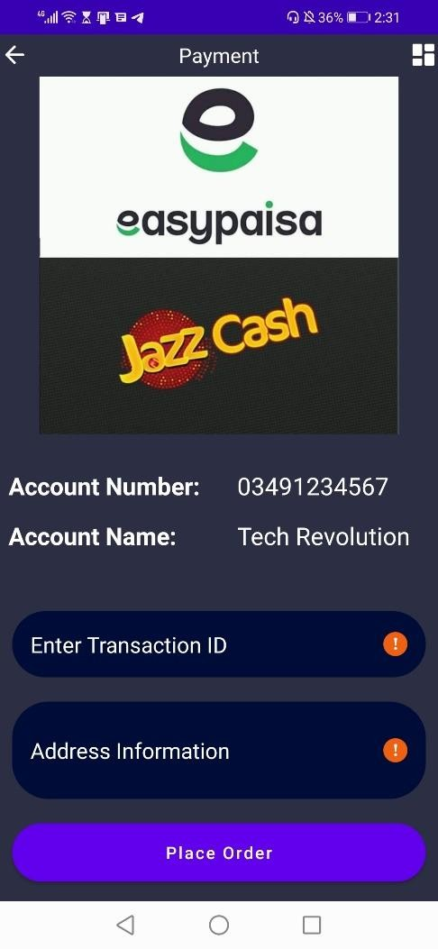

**Note:** The store admin side of the application is accessible from the web portal of our project.

## Merchant Portal

#### Sign Up Process:

1. Fill in the required details
2. Press Register once all correct details are provided
3. User will be prompt with error message if details provided are in incorrect format.



**Login Process:**

1. Enter your login credentials correctly
2. Press Login
3. After successful authentication, the merchant will proceed towards Dashboard Screen/Main Screen.



**Dashboard:**

The dashboard contains three sections. The first section displays the type of orders, the second section displays the current stock and the last section contains the inventory upload button



**Sheet Upload Procedure:**

* 1. The store owner will have to click on the **Choose File** button which will display a screen through which an inventory sheet can be selected:

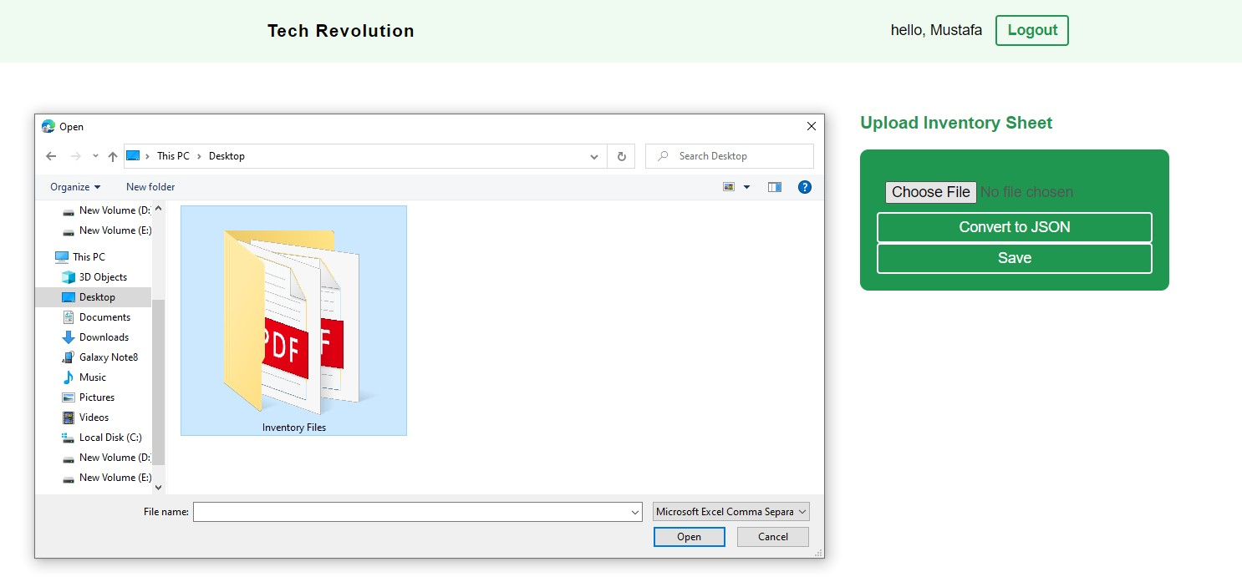

* 1. Once the file is selected, it is displayed right after the button as shown below

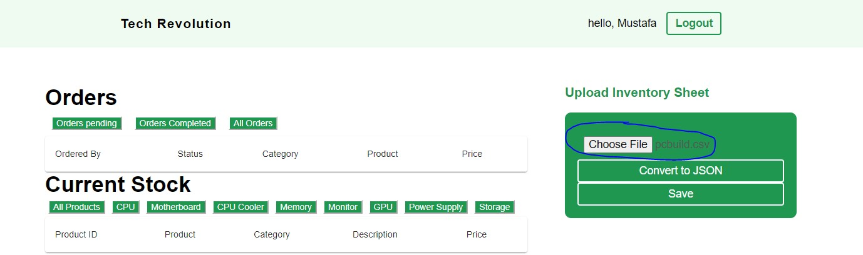

* 1. After selecting the file the merchant will have to press the **Covert to JSON** button which will convert the file into JSON Objects
  2. Once the file is converted to JSON Objects, the merchant will have to press the Save button which will move the data to the database and the inventory current stock section will be populated.

**Dashboard after uploading a file:**

The products are divided into 8 categories

* CPU
* Monitor
* Motherboard
* CPU Cooler
* Memory
* GPU
* Power Supply
* Storage

The merchant can view all products by selecting the **All Products** category

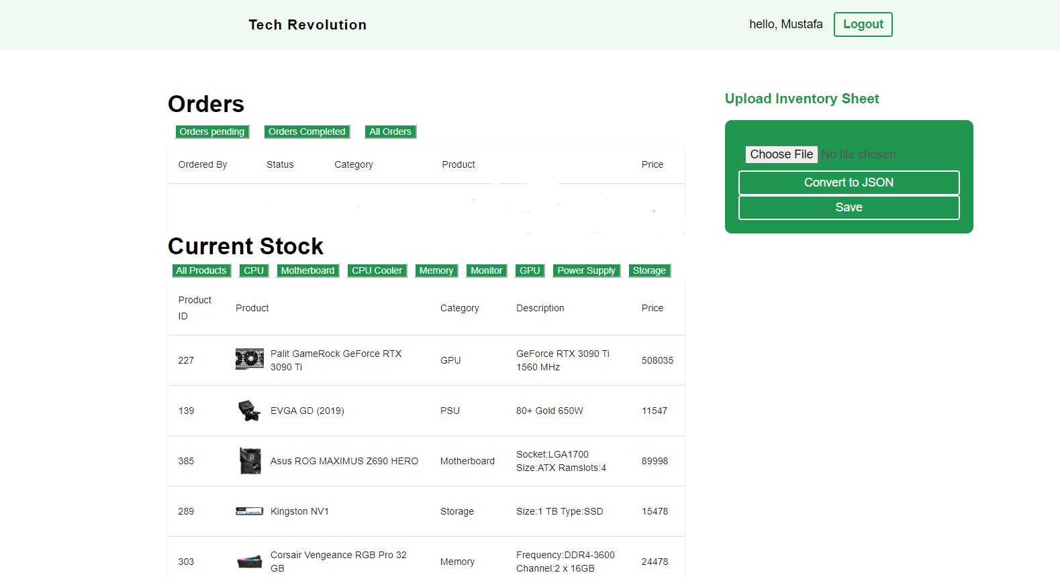

**Orders Section:**

**Orders Pending:**

By clicking on orders pending, the merchant can view the orders having the “Pending” status.

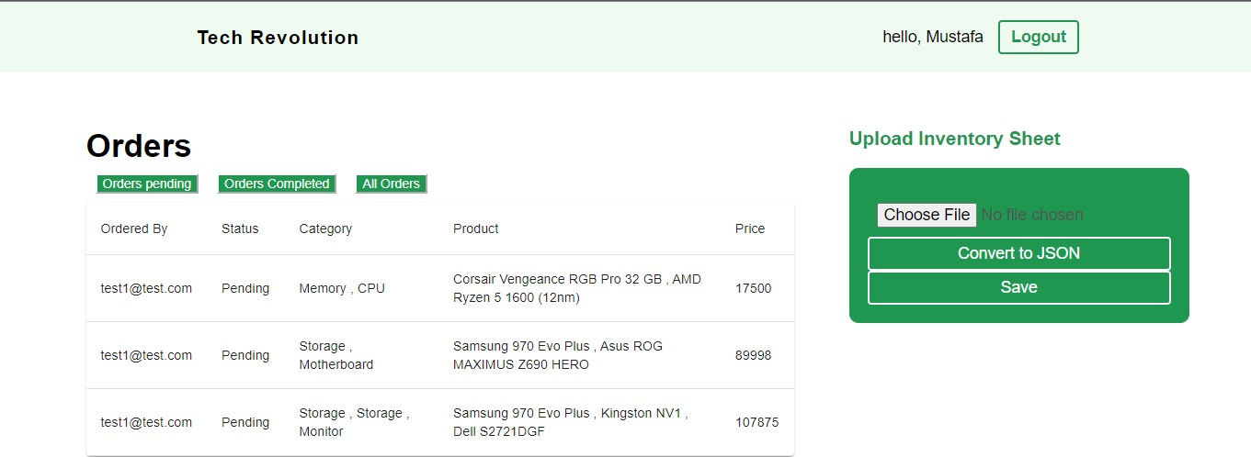

**Orders Completed:**

By clicking on orders completed, the merchant can view the orders having the “Completed” status.

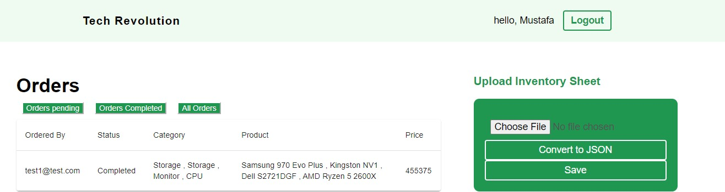

### All Order:

By clicking on all orders, the merchant can view both pending and completed orders.

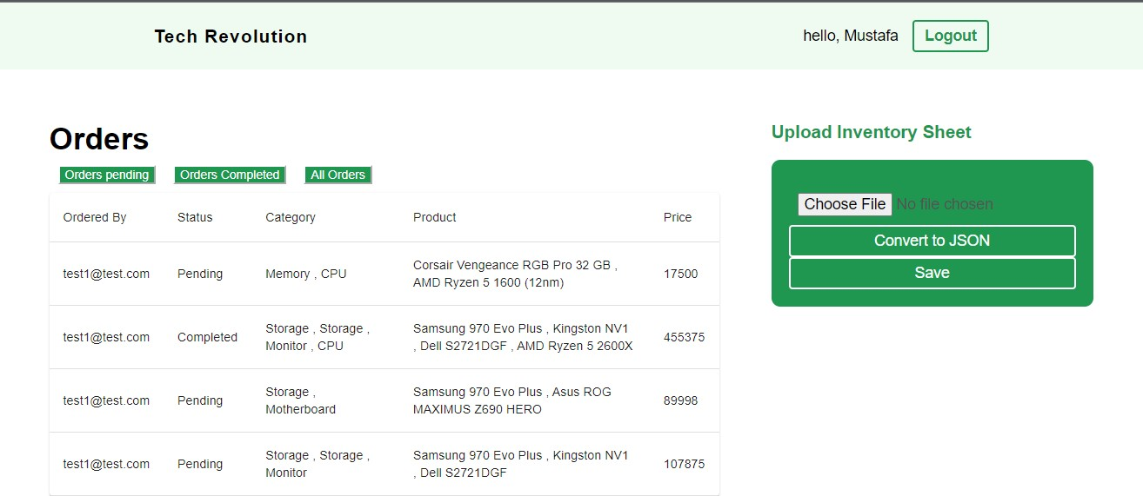

# PROJECT MEETING LOG SHEET

**Form IV: Student Log Form**

Title: **Tech Revolution**

Supervisor: **Muhammad Faizan Tahir** Batch/Sec: **8E** Group #: **90**

Reg. # (Group members):**1812263 (Ghulam Mustafa), 1812268 (M. Abbas Safdar)**

|  |  |  |  |  |
| --- | --- | --- | --- | --- |
| **Sr.** | **Task Assigned** | **Due** | **Task Completed (S)** | **Date (S)/Sign.** |
| 1 | Dataset Collection/Cleansing/Finalization | 28-11-21 | COMPLETED |  |
| 2 | Working on SRS & SDS | 10-12-21 | COMPLETED |  |
| 3 | Android App Login/Signup Work | 7-1-22 | COMPLETED |  |
| 4 | Database Connection With Android App and further UI developments | 27-1-22 | COMPLETED |  |
| 5 | Working on Correlation Model | 6-2-22 | COMPLETED |  |
| 6 | Working on Rating Based Model | 4-4-22 | COMPLETED |  |
| 7 | Android App Further Developments | 10-5-22 | COMPLETED |  |
| 8 | Web Portal Login/Signup Work | 17-5-22 | COMPLETED |  |
| 9 | Web Portal Database Connection | 20-5-22 | COMPLETED |  |
| 10 | Web Portal Sheet Upload Function | 29-5-22 | COMPLETED |  |
| 11 | View Orders Functionality on Web Portal | 3-6-22 | COMPLETED |  |
| 12 | Populating Android App through Web Portal’s Sheet Upload Function | 10-6-22 | COMPLETED |  |
| 13 | Finalization of App and Portal | 14-6-22 | COMPLETED |  |
| 14 | Preparation of Test Cases | 18-6-22 | COMPLETED |  |

Supervisor’s Authentication Dated: (Completed

report):

FYP Coordinator Authentication: Dated:

/

# ITERATION PLAN

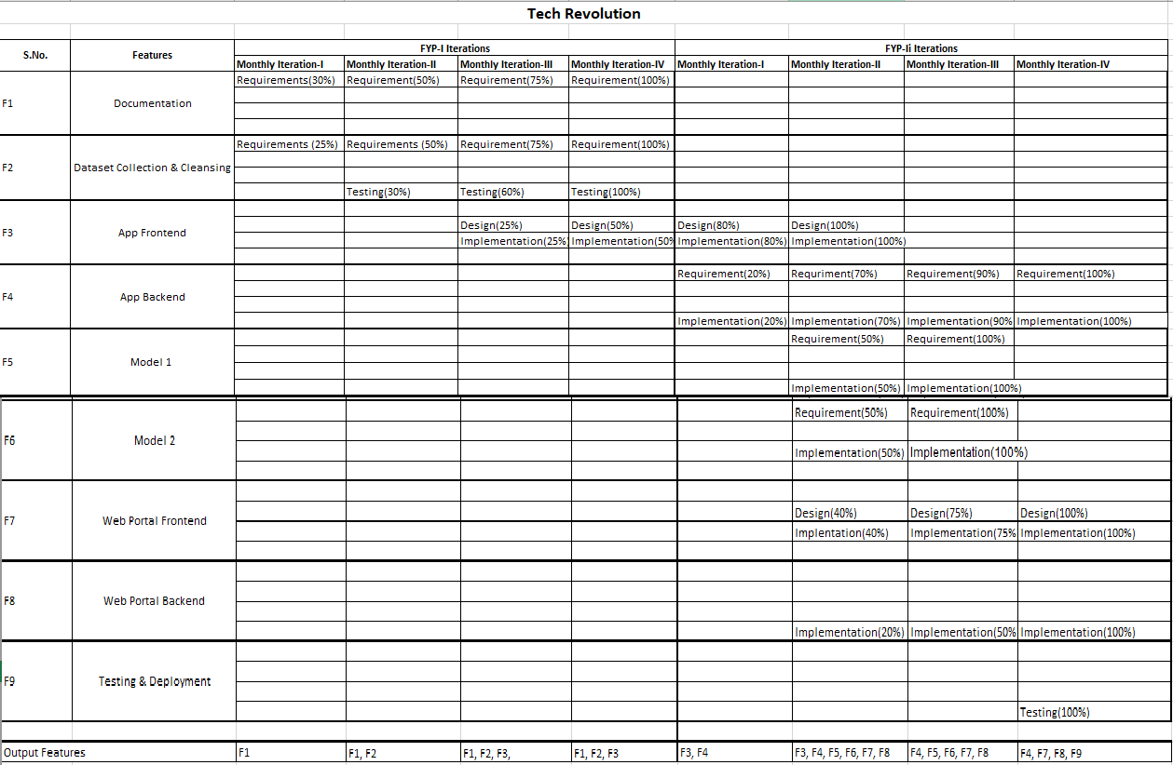

# GANTT CHART



# PLAGIARISM FREE CERTIFICATE

This is to certify that, I Ghulam Mustafa S/0 Muhammad Aslam Shaikh, group leader of Final Year Project “Tech Revolution” under Registration# 1812263 in Computer Science Department, SZABIST, Karachi, declare that my FYP proposal is checked by my supervisor.

Date: 20th June 2022

Name of Group Leader: Ghulam Mustafa Signature:

Name of Supervisor: Muhammad Faizan Tahir

Designation: Lecturer Signature:

# PLAGIARISM CERTIFICATE

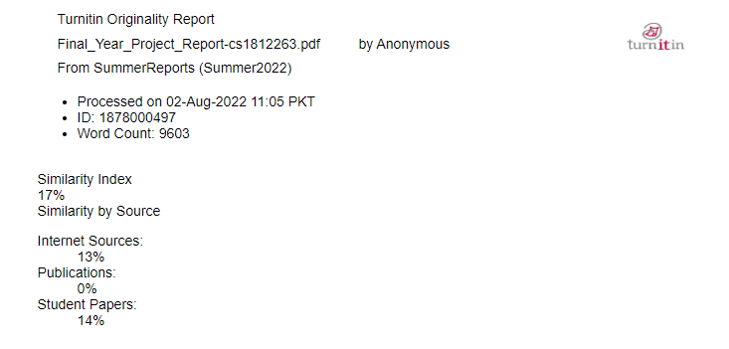

Name of Supervisor: Muhammad Faizan Tahir

Signature: